###### 1. Using SELECT statement find the version of the server you are running and print the name of the current database?

Ans: The below MySQL command will show server version and currently selected Database.

**mysql> SELECT VERSION(), DATABASE();**+-------------------------+------------+| VERSION() | DATABASE() |+-------------------------+------------+| 5.5.34-0ubuntu0.13.10.1 | NULL |+-------------------------+------------+1 row in set (0.06 sec)

In the Database Column it is showing NULL value because we have not selected any database. So, select database as shown in the following command.

**mysql> use Tecmint;**Reading table information for completion of table and column namesYou can turn off this feature to get a quicker startup with -ADatabase changed**mysql> select VERSION(), DATABASE();**+-------------------------+------------+| VERSION() | DATABASE() |+-------------------------+------------+| 5.5.34-0ubuntu0.13.10.1 | tecmint |+-------------------------+------------+1 row in set (0.00 sec)

###### 2. USE NOT Operator (!) to select all the users except ‘SAM’ from a table say ‘Tecmint’

Ans: The below statement will show all the columns of all the users from table ‘Tecmint‘ except the user ‘SAM‘.

**mysql> SELECT * FROM Tecmint WHERE user !=SAM;**+---------------------+---------+---------+---------+---------+-------+ | date | user | host | root | local | size | +---------------------+---------+---------+---------+---------+-------+ | 2001-05-14 14:42:21 | Anthony | venus | barb | venus | 98151 | | 2001-05-15 08:50:57 | TIM | venus | phil | venus | 978 | +---------------------+---------+---------+---------+---------+-------+

###### 3. Is it possible to implement ‘AND’ with NOT (!) Operator.

Ans: The AND operator is used when we use (=) and the operator OR is used when we use (!=). An example of (=) with AND Operator.

**mysql> SELECT * FROM mail WHERE user = SAM AND root = phil**

An Example of (!=) with OR Operator.

**mysql> SELECT * FROM mail WHERE user != SAM OR root != phil**+---------------------+---------+---------+---------+---------+-------+ | date | user | host | root | local | size | +---------------------+---------+---------+---------+---------+-------+ | 2001-05-14 14:42:21 | Anthony | venus | barb | venus | 98151 | +---------------------+---------+---------+---------+---------+-------+

* = : means Equal to
* != : Not Equal to
* ! : represents NOT Operator

The AND & OR are treated as joining operators in MySQL.

###### 4. What IFNULL() statement is used for in MySQL?

Ans: The Query in MySQL can be written precisely using IFNULL() statement. The IFNULL() statement test its first argument and returns if it’s not NULL, or returns its second argument, otherwise.

**mysql> SELECT name, IFNULL(id,'Unknown') AS 'id' FROM taxpayer;**+---------+---------+ | name | id | +---------+---------+ | bernina | 198-48 | | bertha | Unknown | | ben | Unknown | | bill | 475-83 | +---------+---------+

###### 5. You want to see only certain rows from a result set from the beginning or end of a result set. How will you do it?

Ans: We need to use LIMIT clause along with ORDER BY to achieve the above described scenario.

##### Show 1 Record

**mysql> SELECT * FROM name LIMIT 1;**+----+------+------------+-------+----------------------+------+ | id | name | birth | color | foods | cats | +----+------+------------+-------+----------------------+------+ | 1 | Fred | 1970-04-13 | black | lutefisk,fadge,pizza | 0 | +----+------+------------+-------+----------------------+------+

##### Show 5 Record

**mysql> SELECT * FROM profile LIMIT 5;**+----+------+------------+-------+-----------------------+------+ | id | name | birth | color | foods | cats | +----+------+------------+-------+-----------------------+------+ | 1 | Fred | 1970-04-13 | black | lutefisk,fadge,pizza | 0 | | 2 | Mort | 1969-09-30 | white | burrito,curry,eggroll | 3 | | 3 | Brit | 1957-12-01 | red | burrito,curry,pizza | 1 | | 4 | Carl | 1973-11-02 | red | eggroll,pizza | 4 | | 5 | Sean | 1963-07-04 | blue | burrito,curry | 5 | +----+------+------------+-------+-----------------------+------+**mysql> SELECT * FROM profile ORDER BY birth LIMIT 1;**+----+------+------------+-------+----------------+------+ | id | name | birth | color | foods | cats | +----+------+------------+-------+----------------+------+ | 9 | Dick | 1952-08-20 | green | lutefisk,fadge | 0 | +----+------+------------+-------+----------------+------+

###### 6. Oracle Vs MySQL. Which one and Why?

Ans: Well both has its advantages and disadvantages. As a matter of time I prefer MySQL.

##### Reason for Selection MySQL Over oracle

* Mysql is FOSS.
* MySQL is portable.
* MYSQL supports both GUI as well as Command Prompt.
* MySQL Administration is supported over Query Browser.

###### 7. How will you get current date in MySQL?

Ans: Getting current date in MySQL is as simple as executing the below SELECT Statement.

**mysql> SELECT CURRENT_DATE();**+----------------+| CURRENT_DATE() |+----------------+| 2014-06-17 |+----------------+

###### 8. How will you export tables as an XML file in MySQL?

Ans: We use ‘-e‘ (export) option to export MySQL table or the whole database into an XML file. With large tables we may need to implement it manually but for small tables, applications like phpMyAdmin can do the job.

A native command of MySQL can do it.

**mysql -u USER_NAME –xml -e 'SELECT * FROM table_name' > table_name.xml**

Where USER_NAME is username of Database, table_name is the table we are exporting to XML and table_name.xml is the xml file where data is stored.

###### 9. What is MySQL_pconnect? And how it differs from MySQL_connect?

Ans: MySQL_pconnect() opens a connection that is persistent to the MySQL Database which simply means that the database is not opened every-time the page loads and hence we can not use MySQL_close() to close a persistent connection.

A brief difference between MySQL_pconnect and MySQL_connect are.

Unlike MySQL_pconnect, MySQL_connect – Opens the Database every-time the page is loaded which can be closed any-time using statement MySQL_close().

###### 10. You need to show all the indexes defined in a table say ‘user’ of Database say ‘mysql’. How will you achieve this?

Ans: The following command will show all the indexes of a table ‘user’.

**mysql> show index from user;**+-------+------------+----------+--------------+-------------+-----------+-------------+----------+--------+------+------------+---------+---------------+ | Table | Non_unique | Key_name | Seq_in_index | Column_name | Collation | Cardinality | Sub_part | Packed | Null | Index_type | Comment | Index_comment | +-------+------------+----------+--------------+-------------+-----------+-------------+----------+--------+------+------------+---------+---------------+ | user | 0 | PRIMARY | 1 | Host | A | NULL | NULL | NULL | | BTREE | | | | user | 0 | PRIMARY | 2 | User | A | 4 | NULL | NULL | | BTREE | | | +-------+------------+----------+--------------+-------------+-----------+-------------+----------+--------+------+------------+---------+---------------+ 2 rows in set (0.00 sec)

###### 11. What are CSV tables?

Ans: CSV stands for Comma-Separated Values aka Character-Separated Values. CSV table stores data in plain text and tabular format. It typically contains one record per line.

Each record is separated by specific delimiters (Comma, Semi-colon, …) where each record has same sequence of field. CSV tables are most widely used to store phone contacts to Import and Export and can be used to store any sort of plain text data.

That’s all for now. I’ll be here again with another Interesting article, you people will love to read. Till then stay tuned and connected to Tecmint and Don’t forget to provide us with your valuable feedback in the comment section below.

###### 1. Define SQL?

Answer : SQL stands for Structured Query Language. SQL is a programming Language designed specially for managing data in Relational Database Management System (RDBMS).

###### 2. What is RDBMS? Explain its features?

Answer : A Relational Database Management System (RDBMS) is the most widely used database Management System based on the Relational Database model.

###### Features of RDBMS

* Stores data in tables.
* Tables have rows and column.
* Creation and Retrieval of Table is allowed through SQL.

###### 3. What is Data Mining?

Answer : Data Mining is a subcategory of Computer Science which aims at extraction of information from set of data and transform it into Human Readable structure, to be used later.

###### 4. What is an ERD?

Answer : ERD stands for Entity Relationship Diagram. Entity Relationship Diagram is the graphical representation of tables, with the relationship between them.

###### 5. What is the difference between Primary Key and Unique Key?

Answer : Both Primary and Unique Key is implemented for Uniqueness of the column. Primary Key creates a clustered index of column where as an Unique creates unclustered index of column. Moreover, Primary Key doesn’t allow NULL value, however Unique Key does allows one NULL value.

###### 6. How to store picture file in the database. What Object type is used?

Answer : Storing Pictures in a database is a bad idea. To store picture in a database Object Type ‘Blob’ is recommended.

###### 7. What is Data Warehousing?

Answer : A Data Warehousing generally refereed as Enterprise Data Warehousing is a central Data repository, created using different Data Sources.

###### 8. What are indexes in a Database. What are the types of indexes?

Answer : Indexes are the quick references for fast data retrieval of data from a database. There are two different kinds of indexes.

###### Clustered Index

* Only one per table.
* Faster to read than non clustered as data is physically stored in index order.

###### Non­clustered Index

* Can be used many times per table.
* Quicker for insert and update operations than a clustered index.

###### 9. How many TRIGGERS are possible in MySql?

Answer : There are only six triggers are allowed to use in MySQL database and they are.

* Before Insert
* After Insert
* Before Update
* After Update
* Before Delete
* After Delete

###### 10. What is Heap table?

Answer : Tables that are present in the memory are called as HEAP tables. These tables are commonly known as memory tables. These memory tables never have values with data type like “BLOB” or “TEXT”. They use indexes which make them faster.

### Q1. Can you tell the difference between Mysql_connect And Mysql_pconnect?

|  |  |
| --- | --- |
| Mysql_connect | Used to open a new connection to a database. |
|  | You can open and close the database connection based on the request. |
|  | Opens a page everytime the page is loaded. |
| Mysql_connect vs Mysql_pconnect |  |
| Mysql_pconnect | Used to open a persistent connection in a database. |
|  | You cannot close the database connection. |
|  | There is no need to open and close a connection everytime a page is loaded. |

### Q2. What is the default port for MySQL server?

MySQL Server’s default port is *3306*. Apart from this, another standard default port for the SQL Server in TCP/IP is *1433*.

### Q3. Can you tell what are the different set operations available in MySQL?

The various set operations available in MySQL are as follows:

* UNION – This operation returns all the distinct rows selected by a query
* UNION ALL – This operation returns all the rows selected by a query and also includes all duplicate rows.
* MINUS – This operation returns all the distinct rows selected by the first query but does not select the rows selected by the second query.
* INTERSECT – This operation returns all the distinct rows selected by both queries.

Refer to the below image:

### Set Operations - MySQL Interview Questions - EdurekaQ4. Can you tell the order of SQL SELECT statement?

The order of SQL SELECT statement is as follows:

|  |  |
| --- | --- |
| 1 | SELECT, FROM, WHERE, GROUP BY, HAVING, ORDER BY. |

### Q5. What is Database White Box Testing?

The Database Whitebox Testing deals with the tables, data model, schema and referential integrity rules. It also deals with the triggers, logical views with database consistency and ACID properties.

### Q6. What is Database Black Box Testing?

Database Black Box Testing deals with data mapping, data storing and retrieving. The Database Black Box Testing is used for techniques such as Equivalence Partitioning and Boundary Value Analysis.

### Q7. What is CTE?

An expression which consists of a temporary set of results defined in a SQL statement is said to be a Common Table Expression(CTE).

### Q8. What are the different tables present in Mysql?

There are mainly five types of tables present in MySQL. Out of all these database engines, the default database engine used in MySQL is MyISAM. Refer below to know the five types of tables:

* MyISAM
* Heap
* Merge
* INNO DB
* ISAM

### Q9. What is a Cursor?

Considered as a pointer to point to one row in a set of rows, a Cursor is nothing but a control which enables traversal over the records in the table. So, the cursor is used for performing traversing actions such as addition, retrieval, and removal of records in a database.

### Q10. How can you test for NULL values in a database?

A NULL value is a field with no value present in that particular field. Since the NULL value cannot be compared to any other NULL values, you cannot use the comparison operators such as =, <, or <>. To compare the fields with NULL values, you have to use the IS NULL and IS NOT NULL operator.

Refer below for Syntax of IS NULL and IS NOT NULL.

|  |  |
| --- | --- |
| 1  2 | SELECT column_names FROM table_name WHERE column_name IS NULL;  SELECT column_names FROM table_name WHERE column_name IS NOT NULL; |

### Q11. Can you elaborate on BLOB and TEXT in MySQL?

#### BLOB

[BLOB](https://www.edureka.co/blog/mysql-data-types/#String%20Types)(Binary Large Object) is used to hold a variable amount of data and holds up to 65,535 bytes of data. The following are the four types of BLOB.

* TINYBLOB
* BLOB
* MEDIUMBLOB
* LONGBLOB

#### TEXT

TEXT is used to store string values and holds up to a maximum length of 65,535 characters. The following are the four types of TEXT

* TINYTEXT
* TEXT
* MEDIUMTEXT
* LONGTEXT

### Q12. Can you tell how can you display the Maximum salary in SQL?

To display the maximum salary in SQL, you can use the inbuilt function called MAX().

### Q13. What is the difference between the NVL function, IFNULL function, and the ISNULL function?

The NVL function, IFNULL function, and the ISNULL function all of them are used to replace the NULL value with another value. The ORACLE users use the NVL function, MySQL users use the IFNULL function and the SQL servers use the ISNULL function

For example, let us say we have a column(column_3) which has NULL values.

So, if you run the below statement, the output you would get is a NULL value.

|  |  |
| --- | --- |
| 1 | SELECT column_1 * (column_2 + column_3) FROM Example_Table |

Now, to overcome this, you can use the above three functions as follows:

|  |  |
| --- | --- |
| 1  2  3 | SELECT column_1 * (column_2 + NVL(column_3,0)) FROM Example_Table  SELECT column_1 * (column_2 + IFNULL(column_3,0)) FROM Example_Table  SELECT column_1 * (column_2 + ISNULL(column_3,0)) FROM Example_Table |

### Q14. What is the difference between GUI Testing and Database Testing?

|  |  |
| --- | --- |
| GUI Testing | Database Testing |
| Also known as User Interface Testing of Front-end Testing. | Also known as Back-End Testing or Data Testing. |
| Deals with items that interact with users. | Deals with items that are hidden from users. |
| Testers need not know SQL. | Testers need to know SQL. |
| GUI Testing focuses on the outlook of the application | Database Testing focuses on the integrity of data in the front end with the data present in the back end |

### Q15. How To Display Nth Highest Salary From A Table In A Mysql Query?

Consider the table named “Employee”.

Now, to find the Nth salary consider the below statement.



### [MySQL DBA Certification Training](https://www.edureka.co/mysql-dba)

* [*Instructor-led Sessions*](https://www.edureka.co/mysql-dba)
* [*Real-life Case Studies*](https://www.edureka.co/mysql-dba)
* [*Assignments*](https://www.edureka.co/mysql-dba)
* [*Lifetime Access*](https://www.edureka.co/mysql-dba)

[**Explore Curriculum**](https://www.edureka.co/mysql-dba)

|  |  |
| --- | --- |
| 1 | SELECT DISTINCT(salary) FROM employee ORDER BY salary DESC LIMIT n-1,1 |

*So, if you want to find out the 7th largest salary, consider the below query.*

|  |  |
| --- | --- |
| 1 | SELECT DISTINCT(salary) FROM employee ORDER BY salary DESC LIMIT 6,1 |

Now, let’s move on to the next set of questions, which is the [PHP](https://www.edureka.co/blog/php-tutorial-for-beginners/) MySQL Interview Questions.

## PHP MySQL Interview Questions

### Q1. What is the command used to create a database using PHP and MySQL?

The command used to create a database using both PHP and MySQL is *mysql_create_db(“Database Name”).*

### Q2. Can you tell the Difference Between Mysql_fetch_object And Mysql_fetch_array?

Both of them are similar but vary with a single difference. Mysql_fetch_object return as object and Mysql_fetch_array returns an array. This means that you cannot access the data by their offsets but can only access through its fields names.

### Q3: What are the ways in which you can retrieve data in the result set of MySQL using PHP?

The different ways in which you can retrieve data in the result set of MySQL using PHP are as follows:

* mysql_fetch_object: This constant fetches a result row as an object.
* mysql_fetch_array: This constant fetches a result row as an associative array, numeric array or as both.
* mysql_fetch_row: This constant gives us a result row as an enumerated array.
* mysql_fetch_assoc: This constant gives us a result row as an associative array.

### Q4. Can you tell how many values can Set the function of MySQL to consider?

MySQL’s Set function can take a maximum of 64 values, but can also consider 0 values.

### Q5. Can you tell the reasons for selecting Lamp(Linux, Apache, MySQL, PHP) instead of any other combination of software programs, servers, and operating system?

The reason behind selecting Lamp stack is very simple. Linux, Apache, MySQL, PHP are open source software. The security of the Linux operating system is much more than Windows. The Apache server is a better server than others in the perspective of functionalities and security. MySQL is one of the most popular open source databases is used with PHP to perform various functionalities.

### Q6. Can you tell a way to know the number of days between the two given dates in PHP?

You can simply declare the two dates, and then use the *strtotime* function to subtract both the dates and find the differences between the days in seconds.

Consider the below example.

date1 =’2018-09-15′;  
date2 = ‘2018-10-15’;  
days = (strtotime($date1) – strtotime($date2)) / (60 * 60 * 24);

### Q7. Can you tell how to find the number of rows in a resultset using PHP?

You can use the mysql_num_rows function to find the number of rows in a resultset.

Consider the below example.

|  |  |
| --- | --- |
| 1  2  3 | output = mysql_query(sql, database_name);  number_of_rows = mysql_num_rows(output);  echo "The number of forws found are equal to: $number_of_rows"; |

### Q8. What are the functions used to encrypt and decrypt the data present in MySQL?

The function used to encrypt the data is *AES_ENCRYPT()* and the function used to decrypt the data is *AES_DECRYPT()*.

### Q9. If you wish to encrypt the username and password using PHP, how will you do that?

You can encrypt the username and password using the following functions respectively:

|  |  |
| --- | --- |
| 1  2 | SET USERNAME=USERNAME("Username");  SET PASSWORD=PASSWORD(”Password”); |

### Q10. How can you increase the performance of MySQL SELECT query?

The SELECT statement is used to select data from a database and the data returned is stored in a result table, called the result-set. The SELECT statement can be either individually used or can be used with other statements such as ORDER BY, GROUP BY, and HAVING clause.

To increase the performance of a MySQL SELECT query, you can use the LIMIT clause to limit MySQL from further search in a table, after collecting the required number of records. Apart from this, we can also use the LEFT JOIN or the RIGHT JOIN to retrieve data from two or more tables.

### Q11. Can you tell the difference between $message and $$message?

$message and $$message are both PHP variables. $message is used to store the variable data and $$message is used to store the variable of a variable. So basically, data is stored in $message and $$message is used to store the data that can be changed dynamically.

### Q12. Write a program using the SELECT statement, While Loop.

You can write a program to select the students details from the student table and use the loop to just print the name of students.

|  |  |
| --- | --- |
| 1  2  3  4  5 | example_query = mysql_query("SELECT * FROM 'students' WHERE 'student_id' = '1';");  while(output = mysql_fetch_array(example_query))  {  echo output['Students_Name'];  } |

### Q13. How can you take the backup and restore a MySQL database using PHP?

MySQL comes with a utility mysqldump to provide the database backup and restore. The command you can use for backup and restore are as follows respectively.

|  |  |
| --- | --- |
| 1  2  3  4 | //To take the backup of database  mysqldump database > backup -file.sql;  //To restore the database  mysqldump database < backup -file.sql; |

You can also use the phpMyAdmin user interface to backup your database. If you wish to backup, the database you just have to click on the “*export*” link on the phpMyAdmin main page.

### Q14. Can you tell the difference between ereg_replace() and eregi_replace()?

ereg_replace and eregi_repalce() are regular expressions used to replace the matching characters. The only difference between these functions are eregi_replace() function ignores the case distinction when it matches alphabetic characters.

### Q15. How to copy data from one server to another using PHP?

You can use the following three options:

Option 1: You can use the PHP Copy to move files from server to server. Refer to the syntax below:



### [MySQL DBA Certification Training](https://www.edureka.co/mysql-dba)

[**Watch The Course Preview**](https://www.edureka.co/mysql-dba)

|  |  |
| --- | --- |
| 1  2 | /* Copy the file from source url to server */  $copy = copy( $remote_file_url, $local_file ); |

Option 2: You can use the PHP FTP to move files from server to server. Refer to the syntax below.

|  |  |
| --- | --- |
| 1  2 | /* Download $remote_file and save to $local_file */  ftp_get($connect_it,$local_file,$remote_file,FTP_BINARY) |

Option 3: You can use the ZIP and UNZIP Files option in PHP.

Now, let’s move on to the next set of questions, which is the Complex MySQL Interview Questions.

## Complex MySQL Interview Questions

### Q1. Can you tell few best practices to be followed for optimization in SQL?

The best practices to be followed for SQL optimizations depend on the individual to individual, but the following list consists of the most popular practices that are advised to follow. Refer below.

* Try avoiding prefixing your stored procedure names with “sp_”.
* It is recommended to use the column list in INSERT statements.
* Preferably use the ANSI-Standard JOIN Clauses rather than the Old style clauses.
* While using SELECT statement, avoid using * queries.
* Do not use double quotes in T-SQL code.
* Try avoiding to use column numbers in the ORDER BY clause.
* Try using table aliases if your SQL statement involves more than a single source.

### Q2. Can you tell what are various ways to create an index?

The various options to create an index are as follows:

* You can create an index using the T-SQL statements.
* You can use the SQL Server Management Studio. In this, you can browse to the table you need to create an index and then right click on the Indexes node. Over here you have to choose the New Index option.
* You can indirectly identify the index by defining the PRIMARY KEY and the UNIQUE constraint within the CREATE TABLE or ALTER TABLE statement.

### Q3. What is the difference between a Heap table and Temporary table?

|  |  |
| --- | --- |
| Heap Table | Temporary Table |
| Heap Table exists in the memory | A temporary table is valid only during the session. |
| Heap Tables are shared among a various number of clients. | Temporary tables are not shared among the clients. |
| Temporary tables need a special privilege to create tables. | Heap Tables are storage engines which do not need special privileges. |

### Q4. Why do you think it is advised to not to use GUID and CHARACTER columns as Clustered Index arrays?

GUID columns affect the clustered index sorting performance as the nature of the random GUID value generated is larger than the integer data types.

CHARACTER columns affect the sorting performance of the character data types, larger-size values, non-increasing values, and non-static values which often tend to change. These values cannot be compared as binary values, as the characters comparison mechanism depends on the used collection.

### Q5. How can you handle the –secure-file-priv in MySQL?

*–secure-file-priv* option limits the MySQL Server from loading the directories using the LOAD DATA INFILE.

If you wish to see the directory that has been configured then you may use the *SHOW VARIABLES LIKE “secure_file_priv”;*

You have mainly two options to tackle:

* Either move your file to the directory specified by the secure-file-priv.
* Or you can disable secure-file-priv. You cannot disable this later on, and you have to remove it from the start itself.

### Q6. What is the difference between B-Tree and Hash Indexes?

|  |  |
| --- | --- |
| B-Tree | Hash Indexes |
| A B-Tree index can be used for column comparisons like =, >, <, >=, <= or BETWEEN operators. | A Hash-Index can be only used for equality comparisons that use =, >=, <=. |
| B-Tree can be used to search the next entry in the order. | Hash Index cannot be used to search for the next entry in the order. |
| Any leftmost prefix of the key can be used to find the rows. | Only whole keys are used to find a row. |

### Q7. Where is the MyISAM table stored?

Each and every MyISAM Table is stored on disk in the following three files:

* .frm file – Stores the table definition.
* .MYD file – A data file has an MYData extension.
* .MYI index file – The index file has an MYIndex extension.

### Q8.State the differences between MongoDB and MySQL.

|  |  |
| --- | --- |
| MongoDB | MYSQL |
| An open source database that stores JSON like documents which vary in structure. | An open source relational database management system which stores relational data. |
| Each and every individual record are stored as documents. | Each and every individual record are stored as rows in a table. |
| Documents from a particular class or a group are stored in a collection. | A similar type of records are stored in a table. |

### Q9. Identify what is wrong in the below query.

### SELECT EmployeeID, AVG(Salary)

### FROM EmployeeDetails

### WHERE AVG(Salary) > 75

### GROUP BY EmployeeID

The answer is quite simple. You cannot use the WHERE clause to restrict the groups. Instead of this, you have to use the HAVING clause.

Your query should be as follows:

|  |  |
| --- | --- |
| 1  2  3  4 | SELECT EmployeeID, AVG(Salary)  FROM EmployeeDetails  HAVING AVG(Salary) > 75  GROUP BY EmployeeID |

### Q10. What is Normalization and list the different types of normalization?

Normalization is the process of organizing data to avoid duplication and redundancy. There are many successive levels of normalization. These are called normal forms. Each consecutive normal form depends on the previous one. The first three normal forms are usually adequate.

* *First Normal Form (1NF)* – No repeating groups within rows
* *Second Normal Form (2NF)* – Every non-key (supporting) column value is dependent on the whole primary key.
* *Third Normal Form (3NF)* – Dependent solely on the primary key and no other non-key (supporting) column value.

Now, let us move on to the next set of questions which is the Tricky MySQL Interview Questions.

## Tricky MySQL Interview Questions

### Q1. Consider you have a composite index of three columns. Now, you have to provide the value of two columns in the WHERE clause of a SELECT query. Do you think Index can be used for the operation?

Usage of index completely depends on if you consider the primary index or not. Consider you have a student table. Now, suppose if an Index is present on StudentID, StudentFirstName, and StudentLastName then you can consider a query as follows:

|  |  |
| --- | --- |
| 1 | SELECT * FROM StudentDetails WHERE StudentID=3 and StudentFirstName='Jatin' |

Now, if you consider that the above two columns in the query are the secondary index columns, then the index will not be invoked. Else, if the above two columns contain the first column while creating an index(i.e. the primary index), then the index will definitely be invoked.

In the above scenario, I have considered that StudentID and the StudentFirstName as primary columns, so an Index will be used in this case.

### Q2. Suppose you have to collect the first name, middle name and the last name of students from the below table. But, you observe that there few missing values either in the first name, middle name and the last name columns. How will you return the first non-null values?

|  |  |  |  |
| --- | --- | --- | --- |
| StudentID | FirstName | MiddleName | LastName |
| 1 | Rohit | Kumar | NULL |
| 2 | Sakshi | Chowdhary | NULL |
| 3 | NULL | Yash | Singhania |
| 4 | Akash | NULL | Kumar |
| 5 | Avinash | NULL | Daksh |

You can use the COALESCE function to return the first non-null value from the table. Consider the below query.

|  |  |
| --- | --- |
| 1 | SELECT StudentID, COALESCE(FirstName, MiddleName, LastName) as Name FROM StudentDetails; |

### Q3. Consider a scenario where you have two to three tables with thousand tuples in each of them. Now, if you have to perform a JOIN operation between them will you choose to perform filtering of rows or transforming of rows first.

The answer to this question is quite logical. If you have three tables with thousands of tuples in each of them, then you are first supposed to filter the rows in those tables and then transform the table. This would be beneficiary as if you transform the table, then the number of columns may increase reducing the performance. Due to such performance issues, a lot of memory will be used and the output will appear on your screen after quite a long wait of time.

### Q4. How can you validate emails using a single query?

To validate emails you can use the regular expressions function (REGEXP_LIKE). Consider the below query.

|  |  |
| --- | --- |
| 1  2  3  4  5 | SELECT  Email  FROM  Employee  where NOT REGEXP_LIKE(Email, ‘[A-Z0-9._%+-]+@[A-Z0-9.-]+\.[A-Z]{2,4}’, ‘i’); |

### Q5. Consider a scenario where you have to send an email to a client from the SQL database. How do you think you can achieve this task?

To send an email from the database, you can use the stored procedures. Follow the below procedure to send the emails:

* Configure your SQL Server Mail account.
* Enable the database mail.
* Write a script to send an email. Refer below for the script.

|  |  |
| --- | --- |
| 1  2  3  4  5  6 | USE [YourDB]  EXEC msdb.dbo.sp_send_dbmail  @recipients = '[abc@example.com](mailto:abc@example.com); [def@example.com;xyz@example.com’](mailto:def@example.com;xyz@example.com’)  @body = ' Sample Body Text',  @subject = 'Example Email' ;  GO |

### Q6. Consider you have the following three tables which have to be linked together.

### Department(Ssn, EmployeeName, EmployeeAge..)

### EmployeeContactDetails(Ssn, DepartmentID,desc,Ord)

### EmployeeAddress(Ssn,DepartmentID, desc, Ord)

### The problem statement is to select all the departments from the Department table, with the “desc” field from the EmployeeContactDetails and EmployeeAddress where Ord=1. Now, you have to solve this problem statement with a single query.

To solve this problem statement you can use the JOINS concept. You simply have to perform a JOIN on the Department.Ssn and the DepartmentID in the other tables.



### [MySQL DBA Certification Training](https://www.edureka.co/mysql-dba)

[Weekday / Weekend Batches**See Batch Details**](https://www.edureka.co/mysql-dba)

Now, if you are sure that the Ssn exists in all the three considered tables, then you can use the INNER JOIN. Also, if you are not sure that you have matching rows, then you can use the LEFT JOIN. Consider the below query.

|  |  |
| --- | --- |
| 1  2  3  4  5  6  7  8  9  10  11  12 | SELECT d.Ssn,  d.EmployeeName,  c.desc ContactDetailsDesc,  a.desc AddressDetailsDesc  from Department d  inner join EmployeeContactDetails c  on d.id = c.DepartmentID  inner join address a  on d.id = a.DepartmentID  where d.EmployeeName = 'abc'  and c.ord = 1  and a.ord = 1 |

### Q7. If you are assigned a task, to find the information of PROCEDURES. What are the basic commands that you will use to do so?

To check the procedures, you can consider the following query.

|  |  |
| --- | --- |
| 1  2  3 | SELECT * FROM SampleSource  WHERE Type=’PROCEDURE’  AND NAME IN (‘SP_CONNECTED_AGG’,’SP_UNCONNECTED_AGG’); |

To find the procedures columns information, you can consider the following query.

|  |  |
| --- | --- |
| 1 | SELECT OWNER, OBJECT_NAME, ARGUMENT_NAME, DATA_TYPE, IN_OUT from ALL_ARGUMENTS order by OWNER, OBJECT_NAME, SEQUENCE; |

### Q8. Can you tell which of the following WHERE clauses is faster?

WHERE col * 4 < 16

WHERE col < 16 / 4

If we compare both the statements, then the second WHERE clause would be comparatively faster than the first one. That is because, for the first statement, MYSQL would retrieve the value of ‘col’ for each and every row, multiplied by four. After that, it would compare the result to 16. Also, in the first case no Index can be used, and hence it makes it further slow.

### Q9. What is the main difference between ‘BETWEEN’ and ‘IN’ condition operators?

BETWEEN operator is used to display rows based on a range of values in a row whereas the IN condition operator is used to check for values contained in a specific set of values.

#### Example of BETWEEN:

|  |  |
| --- | --- |
| 1 | SELECT * FROM Students where ROLL_NO BETWEEN 10 AND 50; |

#### Example of IN:

|  |  |
| --- | --- |
| 1 | SELECT * FROM students where ROLL_NO IN (8,15,25); |

Q10. What are the different types of Collation Sensitivity?

Following are the different types of collation sensitivity:

* Case Sensitivity
* Kana Sensitivity
* Width Sensitivity
* Accent Sensitivity

So this brings us to the end of the MySQL Interview Questions blog. I hope this set of MySQL Interview Questions will help you ace your job interview. All the best for your interview!

Apart from this MySQL Interview Questions Blog, if you want to get trained from professionals on this technology, you can opt for a structured training from edureka! Click below to know more.

### 1) What is MySQL?

MySQL is a multithreaded, multi-user SQL database management system which has more than 11 million installations. This is the world's second most popular and widely used open source database. It is interesting how MySQL name was given to this query language. The term My is coined by the name of the daughter of co-founder Michael Widenius`s daughter, and SQL is the short form of Structured Query Language. Using MySQL is free of cost for the developer, but enterprises have to pay a license fee to Oracle.

Formerly MySQL was initially owned by a for-profit firm MySQL AB, then Sun Microsystems bought it and then Oracle bought Sun Microsystems, so Oracle currently owns MySQL.

MySQL is an Oracle-supported Relational Database Management System (RDBMS) which is based on structured query language. MySQL supports wide ranges of operating systems most famous of those include Windows, Linux & UNIX. Although it is possible to develop a wide range of application with MySQL, it is only used for web applications & online publishing. It is a fundamental part of an open source enterprise known as Lamp.

**What is Lamp?**

Lamp is a platform used for web development. Lamp uses Linux, Apache, MySQL, and PHP as an operating system, web server, database & object-oriented scripting language respectively. And hence abbreviated as LAMP.

### 2) In which language MySQL has been written?

MySQL is written in C and C++, and its SQL parser is written in yacc.

### 3) What are the technical specifications of MySQL?

MySQL has the following technical specifications -

* Flexible structure
* High performance
* Manageable and easy to use
* Replication and high availability
* Security and storage management
* Drivers
* Graphical Tools
* MySQL Enterprise Monitor
* MySQL Enterprise Security
* JSON Support
* Replication & High-Availability
* Manageability and Ease of Use
* OLTP and Transactions
* Geo-Spatial Support

### 4) What is the difference between MySQL and SQL?

SQL is known as the standard query language. It is used to interact with the database like MySQL. MySQL is a database that stores various types of data and keeps it safe.

A PHP script is required to store and retrieve the values inside the database.

SQL is a computer language, whereas MySQL is a software or an application

SQL is used for the creation of database management systems whereas MySQL is used to enable data handling, storing, deleting and modifying data

### 5) What is the difference between database and table?

There is a major difference between a database and a table. The differences are as follows:

* Tables are a way to represent the division of data in a database while the database is a collection of tables and data.
* Tables are used to group the data in relation with each other and create a dataset. This dataset will be used in the database. The data which are stored in the table in any form is a part of the database, but the reverse is not true.
* A database is a collection of organized data and also features which are used to access them, whereas table is a collection of rows and columns which are used to store the data.

### 6) Why do we use the MySQL database server?

First of all MYSQL server is free to use for developers and a small fee for enterprises.

MySQL server is open source.

The community of MySQL is tremendous and supportive hence any help regarding MySQL is resolved as soon as possible.

MySQL has very stable versions available, as MySQL has been in the market since a long time so all bugs arising in the previous builds have been continuously removed and a very stable version is provided after every update.

The MySQL database server is very fast, reliable and easy to use. You can easily use and modify the software. MySQL software can be downloaded free of cost from the internet.

### 7) What are the different tables present in MySQL?

There are many tables that remain present by default. But, MyISAM is the default database engine used in MySQL. There are five types of tables that are present:

* MyISAM
* Heap
* Merge
* INNO DB
* ISAM

### 8) What is the difference between CHAR and VARCHAR?

A list of differences between CHAR and VARCHAR:

* CHAR is variable-length whereas VARCHAR is of fixed length.
* CHAR and VARCHAR types are different in storage and retrieval.
* CHAR column length is fixed to the length that is declared while creating a table. The length value ranges from 1 and 255.
* When CHAR values are stored when they are right-padded using spaces to a specific length. Trailing spaces are removed when CHAR values are retrieved.
* CHAR uses static memory allocation whereas VARCHAR uses dynamic memory allocation.
* CHAR is 50% faster than VARCHAR.

### 9) What is the difference between TRUNCATE and DELETE in MySQL?

TRUNCATE is a DDL command, DELETE is a DML command.

It is not possible to use Where command with TRUNCATE but you can use it with DELETE command.

TRUNCATE cannot be used with indexed views whereas DELETE can be used with indexed views.

The DELETE command is used to delete data from a table. It only deletes the rows of data from the table while, truncate is very dangerous command and should be used carefully because it deletes every row permanently from a table.

### 10) How many Triggers are possible in MySQL?

There are only six Triggers allowed to use in MySQL database.

1. Before Insert
2. After Insert
3. Before Update
4. After Update
5. Before Delete
6. After Delete

### 11) What is heap table?

Tables that are present in memory is known as HEAP tables. When you create a heap table in MySQL, you should need to specify the TYPE as HEAP. These tables are commonly known as memory tables. They are used for high-speed storage on a temporary basis. They do not allow BLOB or TEXT fields.

### 12) What is BLOB and TEXT in MySQL?

**BLOB** is an acronym stands for a large binary object. It is used to hold a variable amount of data.

There are four types of BLOB.

1. TINYBLOB
2. BLOB
3. MEDIUMBLOB
4. LONGBLOB

The differences among all these are the maximum length of values they can hold.

**TEXT** is a case-insensitive BLOB. TEXT values are non-binary strings (character string). They have a character set, and values are stored, and compared based on the collation of the character set.

There are four types of TEXT.

1. TINYTEXT
2. TEXT
3. MEDIUMTEXT
4. LONGTEXT

### 13) What is a trigger in MySQL?

A trigger is a set of codes that executes in response to some events.

### 14) What is the difference between heap table and temporary table?

**Heap tables:**

Heap tables are found in memory. They are used for high-speed storage on a temporary basis. They do not allow BLOB or TEXT fields.

Heap tables do not support AUTO_INCREMENT.

Indexes should be NOT NULL.

**Temporary tables:**

The temporary tables are used to keep the transient data. Sometimes it is beneficial in cases to hold temporary data. The Temporary table is deleted after the current client session terminates.

**Main differences:**

The heap tables are shared among clients while temporary tables are not shared.

Heap tables are just another storage engine, while for temporary tables you need a special privilege (create temporary table).

### 15) What is the difference between FLOAT and DOUBLE?

FLOAT stores floating point numbers with accuracy up to 8 places and allocates 4 bytes, on the other hand DOUBLE stores floating point numbers with accuracy up to 18 places and allocates 8 bytes.

### 16) What are the advantages of MySQL in comparison to Oracle?

1. MySQL is a free, fast, reliable, open source relational database while Oracle is expensive, although they have provided Oracle free edition to attract MySQL users.
2. MySQL uses only just under 1 MB of RAM on your laptop while Oracle 9i installation uses 128 MB.
3. MySQL is great for database enabled websites while Oracle is made for enterprises.
4. MySQL is portable.

### 17) What are the disadvantages of MySQL?

1. MySQL is not so efficient for large scale databases.
2. It does not support COMMIT and STORED PROCEDURES functions version less than 5.0.
3. Transactions are not handled very efficiently.
4. Functionality of MySQL is highly dependent of other addons.
5. Development is not community driven.

### 18) What is the difference between CHAR and VARCHAR?

1. CHAR and VARCHAR are differ in storage and retrieval.
2. CHAR column length is fixed while VARCHAR length is variable.
3. The maximum no. of character CHAR data type can hold is 255 character while VARCHAR can hold up to 4000 character.
4. CHAR is 50% faster than VARCHAR.
5. CHAR uses static memory allocation while VARCHAR uses dynamic memory allocation.

### 19) What is the difference between MySQL_connect and MySQL_pconnect?

**Mysql_connect:**

1. It opens a new connection to the database.
2. Every time you need to open and close database connection, depending on the request.
3. Opens page whenever it is loaded.

**Mysql_pconnect:**

1. In Mysql_pconnect, "p" stands for persistent connection so it opens the persistent connection.
2. The database connection cannot be closed.
3. It is more useful if your site has more traffic because there is no need to open and close connection frequently and every time when page is loaded.

### 20) What does "i_am_a_dummy flag" do in MySQL?

The "i_am_a_dummy flag" enables MySQL engine to refuse any UPDATE or DELETE statement to execute if the WHERE clause is not present. Hence it can save the programmer from deleting the entire table my mistake if he does not use WHERE clause.

### 21) How to get the current date in MySQL?

To get current date, use the following syntax:

1. **SELECT** **CURRENT_DATE**();

### 22) What are the security alerts while using MySQL?

Install antivirus and configure the operating system's firewall.

Never use the MySQL Server as the UNIX root user.

Change root username and password Restrict or disable remote access.

### 23) How to change a password for an existing user via Mysqladmin?

Mysqladmin -u root -p password "newpassword".

### 24) What is the difference between Unix timestamps and MySQL timestamps?

Actually both Unix timestamp and MySQL timestamp are stored as 32-bit integers but MySQL timestamp is represented in readable format of YYYY-MM-DD HH:MM:SS format.

### 25) How to display Nth highest salary from a table in a MySQL query?

Let us take a table named the employee.

**To find Nth highest salary is:**

**select distinct**(salary)**from** employee **order by** salary **desc** limit n-1,1

if you want to find 3rd largest salary:

**select distinct(salary)from employee order by salary desc limit 2,1**

### 26) What is MySQL default port number?

MySQL default port number is 3306.

### 27) What is REGEXP?

REGEXP is a pattern match using a regular expression. A Regular expression is a powerful way of specifying a pattern for a sophisticated search.

Basically it is a special text string for describing a search pattern. To understand it better you can think of a situation of daily life when you search for .txt files to list all text files in the file manager. The regex equivalent for .txt will be .*\.txt.

### 28) How many columns can you create for an index?

You can create maximum of 16 indexed columns for a standard table.

### 29) What is the difference between NOW() and CURRENT_DATE()?

NOW() command is used to show current year, month, date with hours, minutes and seconds while CURRENT_DATE() shows the current year with month and date only.

### 30) What is the query to display top 20 rows?

**SELECT * FROM** table_name LIMIT 0,20;

### 31) Write a query to display current date and time?

If you want to display current date and time, use -

**SELECT** NOW();

If you want to display current date only, use:

**SELECT CURRENT_DATE**();

### 32) What is save point in MySQL?

A defined point in any transaction is known as savepoint.

SAVEPOINT is a statement in MySQL which is used to set a named transaction save point with a name of identifier.

### 33) What is SQLyog?

SQLyog program is the most popular GUI tool for admin. It is the most popular MySQL manager and admin tool. It combines the features of MySQL administrator, phpMyadmin and others MySQL front ends and MySQL GUI tools.

### 34) How do you backup a database in MySQl?

It is easy to back up data with phpMyAdmin. Select the database you want to backup by clicking the database name in the left-hand navigation bar. Then click the export button and make sure that all tables are highlighted that you want to back up. Then specify the option you want under export and save the output.

### 35) What are the different column comparison operators in MySQL?

The =, <>, <=, <, >=, >, <<, >>, < = >, AND, OR or LIKE operator are the comparison operators in MySQL. These operators are generally used with SELECT statement.

### 36) Write a query to count the number of rows of a table in MySQL.

**SELECT COUNT** user_id FROM users;

### 37) Write a query to retrieve a hundred books starting from 20th.

**SELECT** book_title FROM books LIMIT 20, 100;

### 38) Write a query to select all teams that won either 1, 3, 5 or 7 games.

**SELECT** team_name FROM team WHERE team_won IN (1, 3, 5, 7);

### 39) What is the default port of MySQL Server?

The default port of MySQL Server is 3306.

### 40) How is MyISAM table stored?

MyISAM table is stored on disk in three formats.

* '.frm' file : storing the table definition
* '.MYD' (MYData): data file
* '.MYI' (MYIndex): index file

### 41) What is the usage of ENUMs in MySQL?

ENUMs are string objects, by defining ENUMs we allow the end user to give correct input as in case the user provides an input which is not part of the ENUM defined data then the query won't execute and an error message will be displayed which says "Wrong Query". For instance suppose we want to take the gender of the user as an input so we specify ENUM('male', 'female', 'other') and hence whenever the user tries to input any string any other than these three it results in an error.

ENUMs are used to limit the possible values that go in the table:

**For example:**

CREATE TABLE months (month ENUM 'January', 'February', 'March'); INSERT months VALUES ('April').

### 42) What are the advantages of MyISAM over InnoDB?

MyISAM follows a conservative approach to disk space management and stores each MyISAM table in a separate file, which can be further compresses, if required. On the other hand, InnoDB stores the tables in tablespace. Its further optimization is difficult.

### 43) What are the differences between MySQL_fetch_array(), MySQL_fetch_object(), MySQL_fetch_row()?

Mysql_fetch_object is used to retrieve the result from the database as objects while mysql_fetch_array returns result as an array. This will allow access to the data by the field names.

**For example:**

Using mysql_fetch_object field can be accessed as $result->name.

Using mysql_fetch_array field can be accessed as $result->[name].

Using mysql_fetch_row($result) where $result is the result resource returned from a successful query executed using the mysql_query() function.

**Example:**

1. $result = mysql_query("SELECT * from students");
2. while($row = mysql_fetch_row($result))
3. {
4. Some statement;
5. }

### 44) What is the difference between mysql_connect and mysql_pconnect?

Mysql_connect() is used to open a new connection to the database while mysql_pconnect() is used to open a persistent connection to the database. It specifies that each time the page is loaded mysql_pconnect() does not open the database.

### 45) What is the use of mysql_close()?

Mysql_close() cannot be used to close the persistent connection. Though it can be used to close connection opened by mysql_connect().

### 46) What is MySQL data directory?

MySQL data directory is a place where MySQL stores its data. Each subdirectory under this data dictionary represents a MySQL database. By default the information managed my MySQL = server mysqld is stored in data directory.

### 47) How do you determine the location of MySQL data directory?

The default location of MySQL data directory in windows is C:\mysql\data or C:\Program Files\MySQL\MySQL Server 5.0 \data.

### 48) What is the usage of regular expressions in MySQL?

In MySQL, regular expressions are used in queries for searching a pattern in a string.

* * Matches 0 more instances of the string preceding it.
* + matches one more instances of the string preceding it.
* ? Matches 0 or 1 instances of the string preceding it.
* . Matches a single character.
* [abc] matches a or b or z
* | separates strings
* ^ anchors the match from the start.
* "." Can be used to match any single character. "|" can be used to match either of the two strings
* REGEXP can be used to match the input characters with the database.
* **Example:**
* The following statement retrieves all rows where column employee_name contains the text 1000 (example salary):
  1. **Select** employee_name
  2. **From** employee
  3. **Where** employee_name REGEXP '1000'
  4. **Order** **by** employee_name

### 49) What is the usage of "i-am-a-dummy" flag in MySQL?

In MySQL, the "i-am-a-dummy" flag makes the MySQL engine to deny the UPDATE and DELETE commands unless the WHERE clause is present.

### 50) Which command is used to view the content of the table in MySQL?

The SELECT command is used to view the content of the table in MySQL.

### 51) Explain Access Control Lists.

An ACL is a list of permissions which are associated with an object. MySQL keeps the Access Control Lists cached in memory and whenever the user tries to authenticate or execute a command, MySQL checks the permission required for the object and if the permissions are available then execution completes successfully.

### 52) What is InnoDB?

InnoDB is a storage database for SQL. The ACID-transactions are also provided in addition InnoDB also includes support for the foreign key. Initially owned by InnobaseOY now belongs to Oracle Corporation after it acquired the latter since 2005.

### 53. What is ISAM?

It is a system for file management developed by IBM which allows records to access sequentially or even randomly.

### 54. How can we run batch mode in MySQL?

To perform batch mode in MySQL we use the following command:

mysql;

mysql mysql.out;

### 55. What are federated tables?

Federated tables are tables which points to the tables located on other databases on some other server.

### 56. What is the difference between primary key and candidate key?

To identify each row of a table, a primary key is used. For a table, there exists only one primary key.

A candidate key is a column or a set of columns which can be used to uniquely identify any record in the database without having to reference any other data.

### 57. What are the drivers in MySQL?

Following are the drivers available in MySQL:

* PHP Driver
* JDBC Driver
* ODBC Driver
* C WRAPPER
* PYTHON Driver
* PERL Driver
* RUBY Driver
* CAP11PHP Driver
* Ado.net5.mxz

### 58. What Is DDL, DML, And DCL?

Majorly SQL commands can be divided into three categories i.e. DDL, DML & DCL. Data Definition Language (DDL) deals with all the database schemas, and it defines how the data should reside in the database. Commands like CreateTABLE and ALTER TABLE are part of DDL.

Data Manipulative Language (DML) deals with operations and manipulations on the data the commands in DML are Insert, Select etc.

Data Control Languages (DCL) are related to the Grant and permissions. In short, the authorization to access any part of database is defined by these.

**1. Compare MySQL Vs. SQL Server**

|  |  |  |
| --- | --- | --- |
| **Criteria** | **MySQL** | **SQL Server** |
| Targeted towards | Internet servers & Open Source software | Corporate & Enterprise market |
| Functionality | Speed | Administration, Graphical data modelling |
| Works with | Assumes internet access | Administration, Graphical data modelling |

**2. What is SQL Server?**

SQL Server is one of the Database Management Systems (DBMS) and is designed by Microsoft. DBMS are computer software applications with the capability of interacting with user, various other applications as well as the database itself. The objective is capturing and analyzing data and manages definition, querying, creation, updating as well as administration of database.

Learn for free ! Subscribe to our youtube Channel.



**3. How and why use it?**

SQL Server is free and anyone can download and use it. The application uses SQL (Structured Query Language) and is easy to use.

**4. What are the features of MySQL?**

MySQL provides cross-platform support, wide range of interfaces for application programming and has many stored procedures like triggers and cursors that helps in managing the database.

Go through the [MySQL Video](https://intellipaat.com/php-mysql-training/#course-preview) to get clear understanding of MySQL.

**5. What is traditional Network Library for the system?**

In either Windows or POSIX systems the named pipes provide ways of inter-process communications to connect different processes running on the same machine. It dispenses with the necessity of using the network stack and data can be sent without affecting the performance. Servers set up named pipes to listen to requests. Client process needs to know the specific pipe name to send the request.

**6. What is the default port for MySQL Server?**

The default port for MySQL Server is 3306. Another standard default is port 1433 in TCP/IP for SQL Server.

Learn all about MySQL Server through [this MySQl training course](https://intellipaat.com/php-mysql-training/#about-course).

Become My SQL Certified in 16 hrs.

**GET CERTIFIED**

**7. What do DDL, DML, and DCL stand for?**

DDL is the abbreviation for Data Definition Language dealing with database schemas as well as the description of how data resides in the database. An example is CREATE TABLE command. DML denotes Data Manipulation Language such as SELECT, INSERT etc. DCL stands for Data Control Language and includes commands like GRANT, REVOKE etc.

**8. What are meant by Joins in MySQL?**

In MySQL the Joins are used to query data from two or more tables. The query is made using relationship between certain columns existing in the table. There are four types of Joins in MySQL. Inner Join returns the rows if there is at least one match in both the tables. Left Join returns all the rows form the left table even if there is no match in the right table. Right Join returns all the rows from the right table even if no matches exist in left table. Full Join would return rows when there is at least one match in the tables.

Master MySQL, in [this MySQL certification training](https://intellipaat.com/php-mysql-training/#certification).

**9. What are the common MySQL functions?**

Common MySQL functions are as follows: **• NOWO –** function for returning current date and time as single value. **• CURRDATEO –** function for returning the current date or time. **• CONCAT (X, Y) –** function to concatenates two string values creating single string output. **• DATEDIFF (X, Y) –** function to determine difference two dates.

Become Master of MySQL by going through [this MySQL training course](https://intellipaat.com/php-mysql-training/#course-content).

**10. What is the difference between CHAR and VARCHAR?**

When the table is created, CHAR is used to define the fixed length of the table and columns. The length value could be in the range of 1-255. VARCHAR command is given to adjust the column and table length as required.

**11. What are HEAP Tables?**

Basically HEAP tables are in-memory and used for high speed temporary storages. But TEXT or BLOB fields are not allowed within them. They also do not support AUTO INCREMENT.

[**Learn MySql from Experts! Enrol Today**](https://intellipaat.com/php-mysql-training/#course-content)

**12. What is the syntax for concatenating tables in MySQL?**

The syntax for concatenating tables is MySQL is CONCAT (string 1, string 2, string 3)

**13. What are the limits for using columns to create the Index?**

The maximum limits of indexed columns that could be created for any table is 16.

**14. What are the different types of strings in Database columns in MySQL?**

Different types of strings that can be used for database columns are SET, BLOB, VARCHAR, TEX, ENUM, and CHAR.

**15. How the user can get the current SQL version?**

The syntax for getting the current version of MySQL is SELECT VERSION ();

**16. Is there an object oriented version of MySQL library functions?**

MySQLi is the object oriented version of MySQL and it interfaces in PHP.

**17. What is the storage engine for MySQL?**

Storage tables are named as table types. The data is stored in the files using multiple techniques such as indexing, locking levels, capabilities and functions.

**18. What is the difference between primary key and candidate key?**

Primary key in MySQL is use to identify every row of a table in unique manner. For one table there is only one primary key. One of the candidate keys is the primary key and the candidate keys can be used to reference the foreign keys.

**19. What are the different types of tables in MySQL?**

MyISAM is the default table that is based on the sequential access method.

* **HEAP** is the table that is used for fast data access but data will be lost if the table or system crashes.
* **InoDB** is the table that supports transactions using the COMMIT and ROLL BACK commands.
* **BDB** can support transactions similar to InoDB but the execution is slower.

**20. Can you use MySQL with LINUX operating system?**

Yes, the syntax for using MySQL with LINUX operating system is /etc/init.d/mysqlstart

**21. What is the use of ENUM in MySQL?**

Use of ENUM will limit the values that can go into a table. For instance; the user can create a table giving specific month values and other month values would not enter into the table.

**22. What are the TRIGGERS that can be used in MySQL tables?**

The following TRIGGERS are allowed in MySQL:• BEFORE INSERT

* AFTER INSERT
* BEFORE UPDATE
* AFTER UPDATE
* BEFORE DELETE
* AFTER DELETE

**23. What is the difference between LIKE and REGEXP operators in MySQL?**

* LIKE is denoted using the % sign. For example:SELECT * FROM user WHERE user name LIKE “%NAME”.• On the other hand the use of REGEXP is as follows:SELECT * FROM user WHERE username REGEXP “^NAME”;

**24. How to use the MySQL slow query log?**

Information that is provided on the slow query log could be huge in size. The query could also be listed over thousand times. In order to summarize the slow query log in an informative manner one can use the third party tool “pt-qury-digest”.

**25. How can one take incremental backup in MySQL?**

User can take incremental backup in MySQL using percona xtrabackup.

**26. How can you change the root password if the root password is lost?**

In such cases when the password is lost the user should start the DB with – skip-grants-table and then change the password. Thereafter with the new password the user should restart the DB in normal mode.

**27. How to resolve the problem of data disk that is full?**

When the data disk is full and overloaded the way out is to create and soft link and move the .frm as well as the .idb files into that link location.

**28. What is the difference between DELETE TABLE and TRUNCATE TABLE commands in MySQL?**

Basically DELETE TABLE is logged operation and every row deleted is logged. Therefore the process is usually slow. TRUNCATE TABLE also deletes rows in a table but it will not log any of the rows deleted. The process is faster in comparison. TRUNCATE TABLE can be rolled back and is functionally similar to the DELETE statement using no WHERE clause.

**29. What are types of joins in MySQL?**

There are four types of Joins in MySQL. Inner Join returns the rows if there is at least one match in both the tables. Left Join returns all the rows form the left table even if there is no match in the right table. Right Join returns all the rows from the right table even if no matches exist in left table. Full Join would return rows when there is at least one match in the tables.

**30.What are the storage models of OLAP?**

The storage models in OLA are MOLAP, ROLAP, and HOLAP.

**31. How to define testing of network layers in MySQL?**

For this it is necessary reviewing the layered architecture and determining hardware and software configuration dependencies in respect of the application put to test.

**32. What is the difference between primary key and unique key?**

While both are used to enforce uniqueness of the column defined but primary key would create a clustered index whereas unique key would create non-clustered index on the column. Primary key does not allow ‘NULL’ but unique key allows it.

**33. What is meant by transaction and ACID properties?**

Transaction is logical unit of work where either all or none of the steps should be performed. ACID is the abbreviation for Atomicity, Consistency, Isolation, and Durability that are properties of any transaction.

**34. How can one restart SQL Server in single user or minimal configuration modes?**

The command line SQLSERVER.EXE used with –m will restart SQL Server in single user mode and with –f will start it in minimal configuration mode.

**35. What is the difference between BLOB and TEXT?**

BLOBs are binary large object holding huge data. 4 types of BLOB are TINYBLOB, BLOB, MEDIBLOB, and LONGBLOB. TEXT is case-sensitive BLOB. 4 types of TEXT are TINY TEXT, TEXT, MEDIUMTEXT, and LONG TEXT.

**36. What is the basic MySQL architecture?**

The logical architecture of MySQL is made of ‘connection manager’, ‘query optimizer’, and ‘pluggable engines’.

**1. What is MySQL?**

MySQL is an open source DBMS which is built, supported and distributed by MySQL AB (now acquired by Oracle)

**2. What are the technical features of MySQL?**

MySQL database software is a client or server system which includes

* Multithreaded SQL server supporting various client programs and libraries
* Different backend
* Wide range of application programming interfaces and
* Administrative tools.

**3. Why MySQL is used?**

MySQL database server is reliable, fast and very easy to use. This software can be downloaded as freeware and can be downloaded from the internet.

**4. What are Heap tables?**

HEAP tables are present in memory and they are used for high speed storage on temporary

basis.

• BLOB or TEXT fields are not allowed

• Only comparison operators can be used =, <,>, = >,=<

• AUTO_INCREMENT is not supported by HEAP tables

• Indexes should be NOT NULL

**5. What is the default port for MySQL Server?**

The default port for MySQL server is 3306.



**6. What are the advantages of MySQL when compared with Oracle?**

* MySQL is open source software which is available at any time and has no cost involved.
* MySQL is portable
* GUI with command prompt.
* Administration is supported using MySQL Query Browser

**7. Differentiate between FLOAT and DOUBLE?**

Following are differences for FLOAT and DOUBLE:

• Floating point numbers are stored in FLOAT with eight place accuracy and it has four bytes.

• Floating point numbers are stored in DOUBLE with accuracy of 18 places and it has eight bytes.

**8. Differentiate CHAR_LENGTH and LENGTH?**

CHAR_LENGTH is character count whereas the LENGTH is byte count. The numbers are same for Latin characters but they are different for Unicode and other encodings.

**9. How to represent ENUMs and SETs internally?**

ENUMs and SETs are used to represent powers of two because of storage optimizations.

**10. What is the usage of ENUMs in MySQL?**

ENUM is a string object used to specify set of predefined values and that can be used during table creation.

|  |  |
| --- | --- |
| 1 | Create table size(name ENUM('Small', 'Medium','Large'); |

**11. Define REGEXP?**

REGEXP is a pattern match in which matches pattern anywhere in the search value.

**12. Difference between CHAR and VARCHAR?**

Following are the differences between CHAR and VARCHAR:

* CHAR and VARCHAR types differ in storage and retrieval
* CHAR column length is fixed to the length that is declared while creating table. The length value ranges from 1 and 255
* When CHAR values are stored then they are right padded using spaces to specific length. Trailing spaces are removed when CHAR values are retrieved.

**13. Give string types available for column?**

The string types are:

* SET
* BLOB
* ENUM
* CHAR
* TEXT
* VARCHAR

**14. How to get current MySQL version?**

|  |  |
| --- | --- |
| 1 | SELECT VERSION (); |

is used to get the current version of MySQL.

**15. What storage engines are used in MySQL?**

Storage engines are called table types and data is stored in files using various techniques.

Technique involves:

* Storage mechanism
* Locking levels
* Indexing
* Capabilities and functions.

**16. What are the drivers in MySQL?**

Following are the drivers available in MySQL:

* PHP Driver
* JDBC Driver
* ODBC Driver
* C WRAPPER
* PYTHON Driver
* PERL Driver
* RUBY Driver
* CAP11PHP Driver
* Ado.net5.mxj

**17. What does a TIMESTAMP do on UPDATE CURRENT_TIMESTAMP data type?**

TIMESTAMP column is updated with Zero when the table is created. UPDATE CURRENT_TIMESTAMP modifier updates the timestamp field to current time whenever there is a change in other fields of the table.

**18. What is the difference between primary key and candidate key?**

Every row of a table is identified uniquely by primary key. There is only one primary key for a table.

Primary Key is also a candidate key. By common convention, candidate key can be designated as primary and which can be used for any foreign key references.

**19. How do you login to MySql using Unix shell?**

We can login through this command:

# [mysql dir]/bin/mysql -h hostname -u <UserName> -p <password>

**20. What does myisamchk do?**

It compress the MyISAM tables, which reduces their disk or memory usage.

**21. How do you control the max size of a HEAP table?**

Maximum size of Heal table can be controlled by MySQL config variable called max_heap_table_size.

**22. What is the difference between MyISAM Static and MyISAM Dynamic?**

In MyISAM static all the fields will have fixed width. The Dynamic MyISAM table will have fields like TEXT, BLOB, etc. to accommodate the data types with various lengths.

MyISAM Static would be easier to restore in case of corruption.

**23. What are federated tables?**

Federated tables which allow access to the tables located on other databases on other servers.

**24. What, if a table has one column defined as TIMESTAMP?**

Timestamp field gets the current timestamp whenever the row gets altered.

**25. What happens when the column is set to AUTO INCREMENT and if you reach maximum value in the table?**

It stops incrementing. Any further inserts are going to produce an error, since the key has been used already.

**26. How can we find out which auto increment was assigned on Last insert?**

LAST_INSERT_ID will return the last value assigned by Auto_increment and it is not required to specify the table name.

**27. How can you see all indexes defined for a table?**

Indexes are defined for the table by:

SHOW INDEX FROM <tablename>;

**28. What do you mean by % and _ in the LIKE statement?**

% corresponds to 0 or more characters, _ is exactly one character in the LIKE statement.

**29. How can we convert between Unix & MySQL timestamps?**

UNIX_TIMESTAMP is the command which converts from MySQL timestamp to Unix timestamp

FROM_UNIXTIME is the command which converts from Unix timestamp to MySQL timestamp.

**30. What are the column comparisons operators?**

The = , <>, <=, <, >=, >,<<,>>, <=>, AND, OR, or LIKE operators are used in column comparisons in SELECT statements.

**31. How can we get the number of rows affected by query?**

Number of rows can be obtained by

|  |  |
| --- | --- |
| 1 | SELECT COUNT (user_id) FROM users; |

**32. Is Mysql query is case sensitive?**

No.

|  |  |
| --- | --- |
| 1  2  3 | SELECT VERSION(), CURRENT_DATE;  SeLect version(), current_date;  seleCt vErSiOn(), current_DATE; |

All these examples are same. It is not case sensitive.

**33. What is the difference between the LIKE and REGEXP operators?**

LIKE and REGEXP operators are used to express with ^ and %.

|  |  |
| --- | --- |
| 1  2 | SELECT * FROM employee WHERE emp_name REGEXP "^b";  SELECT * FROM employee WHERE emp_name LIKE "%b"; |

**34. What is the difference between BLOB AND TEXT?**

A BLOB is a binary large object that can hold a variable amount of data. There are four types of BLOB –

* TINYBLOB
* BLOB
* MEDIUMBLOB and
* LONGBLOB

They all differ only in the maximum length of the values they can hold.

A TEXT is a case-insensitive BLOB. The four TEXT types

* TINYTEXT
* TEXT
* MEDIUMTEXT and
* LONGTEXT

They all correspond to the four BLOB types and have the same maximum lengths and storage requirements.

The only difference between BLOB and TEXT types is that sorting and comparison is performed in case-**sensitive** for BLOB values and case-**insensitive** for TEXT values.

**35. What is the difference between mysql_fetch_array and mysql_fetch_object?**

Following are the differences between mysql_fetch_array and mysql_fetch_object:

mysql_fetch_array() -Returns a result row as an associated array or a regular array from database.

mysql_fetch_object – Returns a result row as object from database.

**36. How can we run batch mode in mysql?**

Following commands are used to run in batch mode:

|  |  |
| --- | --- |
| 1  2 | mysql ;  mysql mysql.out |

**37. Where MyISAM table will be stored and also give their formats of storage?**

Each MyISAM table is stored on disk in three formats:

* The ‘.frm’ file stores the table definition
* The data file has a ‘.MYD’ (MYData) extension
* The index file has a ‘.MYI’ (MYIndex) extension

**38. What are the different tables present in MySQL?**

Total 5 types of tables are present:

* MyISAM
* Heap
* Merge
* INNO DB
* ISAM

MyISAM is the default storage engine as of MySQL .

**39. What is ISAM?**

ISAM is abbreviated as Indexed Sequential Access Method.It was developed by IBM to store and retrieve data on secondary storage systems like tapes.

**40. What is InnoDB?**

lnnoDB is a transaction safe storage engine developed by Innobase Oy which is a Oracle Corporation now.

**41. How MySQL Optimizes DISTINCT?**

DISTINCT is converted to a GROUP BY on all columns and it will be combined with ORDER BY clause.

|  |  |
| --- | --- |
| 1 | SELECT DISTINCT t1.a FROM t1,t2 where t1.a=t2.a; |

**42. How to enter Characters as HEX Numbers?**

If you want to enter characters as HEX numbers, you can enter HEX numbers with single quotes and a prefix of (X), or just prefix HEX numbers with (Ox).

A HEX number string will be automatically converted into a character string, if the expression context is a string.

**43. How to display top 50 rows?**

In MySql, top 50 rows are displayed by using this following query:

|  |  |
| --- | --- |
| 1  2 | SELECT * FROM  LIMIT 0,50; |

**44. How many columns can be used for creating Index?**

Maximum of 16 indexed columns can be created for any standard table.

**45. What is the different between NOW() and CURRENT_DATE()?**

NOW () command is used to show current year,month,date with hours,minutes and seconds.

CURRENT_DATE() shows current year,month and date only.

**46. What are the objects can be created using CREATE statement?**

Following objects are created using CREATE statement:

* DATABASE
* EVENT
* FUNCTION
* INDEX
* PROCEDURE
* TABLE
* TRIGGER
* USER
* VIEW

**47. How many TRIGGERS are allowed in MySql table?**

SIX triggers are allowed in MySql table. They are as follows:

* BEFORE INSERT
* AFTER INSERT
* BEFORE UPDATE
* AFTER UPDATE
* BEFORE DELETE and
* AFTER DELETE

**48. What are the nonstandard string types?**

Following are Non-Standard string types:

* TINYTEXT
* TEXT
* MEDIUMTEXT
* LONGTEXT

**49. What are all the Common SQL Function?**

CONCAT(A, B) – Concatenates two string values to create a single string output. Often used to combine two or more fields into one single field.

FORMAT(X, D) – Formats the number X to D significant digits.

CURRDATE(), CURRTIME() – Returns the current date or time.

NOW() – Returns the current date and time as one value.

MONTH(), DAY(), YEAR(), WEEK(), WEEKDAY() – Extracts the given data from a date value.

HOUR(), MINUTE(), SECOND() – Extracts the given data from a time value.

DATEDIFF(A, B) – Determines the difference between two dates and it is commonly used to calculate age

SUBTIMES(A, B) – Determines the difference between two times.

FROMDAYS(INT) – Converts an integer number of days into a date value.

**50. Explain Access Control Lists.**

An ACL (Access Control List) is a list of permissions that is associated with an object. This list is the basis for MySQL server’s security model and it helps in troubleshooting problems like users not being able to connect.

MySQL keeps the ACLs (also called grant tables) cached in memory. When a user tries to authenticate or run a command, MySQL checks the authentication information and permissions against the ACLs, in a predetermined order.

**Q #3) What is the default port number of MySQL?**

**Answer:**

The default port number of MySQL is **3306**.

**Q #4) How can you find out the version of the installed MySQL?**

**Answer:**

The version of the installed MySQL server can be found out easily by running the following command from the MySQL prompt.

mysql> SHOW VARIABLES LIKE “%version%”;

**Q #5) What are the advantages and disadvantages of using MySQL?**

**Answer:**

There are several advantages of MySQL which are making it a more popular database system now.

Some significant advantages and disadvantages of MySQL are mentioned below.

**Advantages:**

* It is well-known for its reliable and secure database management system. Transactional tasks of the website can be done more securely by using this software.
* It supports different types of storage engines to store the data and it works faster for this feature.
* It can handle millions of queries with a high-speed transactional process.
* It supports many advanced level database features, such as multi-level transaction, data integrity, deadlock identification etc.
* Maintenance and debugging process are easier for this software.

**Disadvantages:**

* It is hard to make MySQL scalable.
* It is not suitable for a very large type of database.
* The uses of stored routine and trigger are limited to MySQL.

**Q #6) What is the function of myisamchk?**

**Answer:**

myisamchk is a useful database utility tool that is used to get information about MyISAM database tables.

It is also used for checking, debugging, repairing and optimizing database tables. It is better to use this command when the server is down or when the required tables are not in use by the server.

**Syntax:**

**myisamchk [OPTION] table_name…**

The available options of this tool can be retrieved by using the following command.

**myisamchk –help**

To check or repair all MyISAM tables, the following command will be required for executing from the database directory location.

**myisamchk *.MYI**

**Q #7) What are the purposes of using ENUM and SET data types?**

**Answer:**

ENUM data type is used in the MySQL database table to select any one value from the predefined list.

The value of a particular field can be restricted by defining the predefined list as the field which is declared as ENUM will not accept any value outside the list.

The SET data type is used to select one or more or all values from the predefined list. This data type can also be used to restrict the field for inserting only the predefined list of values like ENUM.

**Example:**

Run MySQL server from the command prompt and execute the following SQL commands to know the use of ENUM and SET data type.

The following SQL commands create a new database named ‘**newdb**’ and select the database for use.

**CREATE DATABASE newdb;**

**USE newdb;**

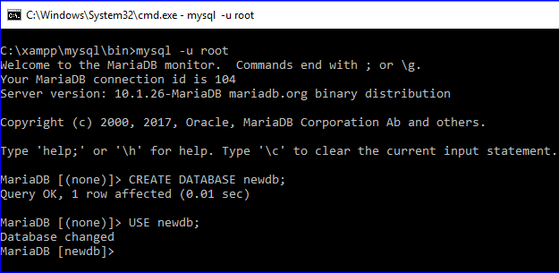

The following SQL command will create a table named **clients** with the fields ENUM and SET data type.

|  |  |
| --- | --- |
| 1 | **CREATE** **TABLE** clients ( |

|  |  |
| --- | --- |
| 2 | id **INT** AUTO_INCREMENT **PRIMARY** **KEY**, |

|  |  |
| --- | --- |
| 3 | **name** **VARCHAR**(50), |

|  |  |
| --- | --- |
| 4 | membership ENUM('Silver', 'Gold', 'Diamond'), |

|  |  |
| --- | --- |
| 5 | interest **SET**('Movie', 'Music', 'Concert')); |

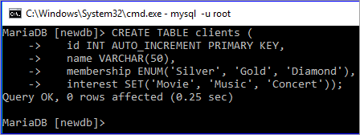

Insert query will create two records in the table. ENUM field only accepts data from the defined list.

‘**Premium**’ value does not exist on the ENUM list. Hence, the value of the ENUM field will be empty for the second record. SET can accept multiple values and both the data will be inserted in the second record.

|  |  |
| --- | --- |
| 1 | **INSERT** **INTO** clients (**name**, membership,interest) |

|  |  |
| --- | --- |
| 2 | **VALUES** ('Sehnaz','Gold', 'Music'), |

|  |  |
| --- | --- |
| 3 | ('Sourav','Premium', 'Movie,Concert'); |

|  |  |
| --- | --- |
| 4 | **SELECT** * **FROM** clients; |

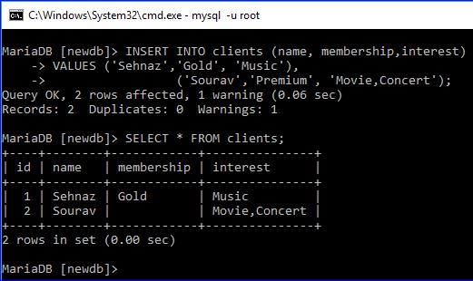

**Q #8) What are the differences between a primary key and foreign key?**

**Answer:**

Database table uses a primary key to identify each row uniquely. It is necessary to declare the primary key on those tables that require to create a relationship among them. One or more fields of a table can be declared as the primary key.

When the primary key of any table is used in another table as the primary key or another field for making a database relation, then it is called a foreign key.

**The differences between these two keys are mentioned below.**

* The primary key uniquely identifies a record, whereas foreign key refers to the primary key of another table.
* The primary key can never accept a NULL value but foreign key accepts a NULL value.
* When a record is inserted in a table that contains the primary key then it is not necessary to insert the value on the table that contains this primary key field as the foreign key.
* When a record is deleted from the table that contains the primary key then the corresponding record must be deleted from the table containing the foreign key for data consistency. But any record can be deleted from the table that contains a foreign key without deleting a related record of another table.

**Example:**

Two tables named **manufacturers** and **items** will be created after executing the following two SQL commands.

Here, the primary key of the **manufacturers** table is used as foreign key in the **items** table with the field name **manufacturer_id**. Hence, the **manufacturer_id** field will contain only those values that exist in the **manufacturers** table.

|  |  |
| --- | --- |
| 1 | **CREATE** **TABLE** manufacturers ( |

|  |  |
| --- | --- |
| 2 | id **INT** AUTO_INCREMENT **PRIMARY** **KEY**, |

|  |  |
| --- | --- |
| 3 | **name** **VARCHAR**(50)); |

|  |  |
| --- | --- |
| 4 | **CREATE** **TABLE** items ( |

|  |  |
| --- | --- |
| 5 | id **INT** AUTO_INCREMENT **PRIMARY** **KEY**, |

|  |  |
| --- | --- |
| 6 | **name** **VARCHAR**(50), |

|  |  |
| --- | --- |
| 7 | type **VARCHAR**(50), |

|  |  |
| --- | --- |
| 8 | brand **VARCHAR**(50), |

|  |  |
| --- | --- |
| 9 | manufacturer_id **INT**, |

|  |  |
| --- | --- |
| 10 | **FOREIGN** **KEY** (manufacturer_id) **REFERENCES** manufacturers(id)); |

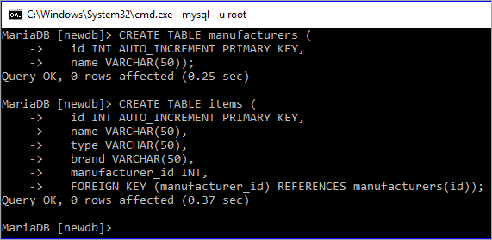

**Q #9) What are the differences between CHAR and VARCHAR data types?**

**Answer:**

Both CHAR and VARCHAR data types are used to store string data in the field of the table.

**The differences between these data types are mentioned below:**

* CHAR data type is used to store fixed-length string data and VARCHAR data type is used to store variable-length string data.
* The storage size of CHAR data type will always be the maximum length of this data type and the storage size of VARCHAR will be the length of the inserted string data. Hence, it is better to use the CHAR data type when the length of the string will be the same length for all the records.
* CHAR is used to store small data whereas VARCHAR is used to store large data.
* CHAR works faster and VARCHAR works slower.

**Example:**

The following SQL statement will create a table named customers. In this table, the data type of **name** field is VARCHAR and the data type of **phone** field is CHAR.

The size of the **name** field will depend on the length of the inserted value. The size of the **phone** field will always be 14 characters even if the length of the inserted value is less than 14 characters.

|  |  |
| --- | --- |
| 1 | **CREATE** **TABLE** customers ( |

|  |  |
| --- | --- |
| 2 | id **INT** AUTO_INCREMENT **PRIMARY** **KEY**, |

|  |  |
| --- | --- |
| 3 | **name** **VARCHAR**(50), |

|  |  |
| --- | --- |
| 4 | phone **CHAR**(14)) |

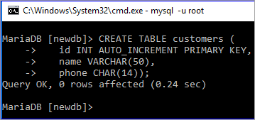

**Q #10) What is the purpose of using TIMESTAMP data type?**

**Answer:**

A TIMESTAMP data type is used to store the combination of date and time value which is 19 characters long.

The format of TIMESTAMP is YYYY-MM-DD HH:MM: SS. It can store data from ‘1970-01-01 00:00:01’ UTC to ‘2038-01-19 03:14:07’ UTC. By default, the current date and time of the server get inserted in the field of this data type when a new record is inserted or updated.

**Q #11) What is the difference between mysql_fetch_array() and ysql_fetch_object() ?**

**Answer:**

Both mysql_fetch_array() and mysql_fetch_object() are built-in methods of PHP to retrieve records from MySQL database table.

The difference between these methods is that mysql_fetch_array() returns the result set as an array and mysql_fetch_object() returns the result set as an object.

**Example:**

|  |  |
| --- | --- |
| 1 | $result = mysql_query("SELECT id, name FROM clients"); |

|  |  |
| --- | --- |
| 2 |  |

|  |  |
| --- | --- |
| 3 | //using mysql_fetch_array() |

|  |  |
| --- | --- |
| 4 | while ($row = mysql_fetch_array($result, MYSQL_NUM)) { |

|  |  |
| --- | --- |
| 5 | printf("ID: %s Name: %s", $row[0], $row[1]); |

|  |  |
| --- | --- |
| 6 | } |

|  |  |
| --- | --- |
| 7 |  |

|  |  |
| --- | --- |
| 8 | //using mysql_fetch_object() |

|  |  |
| --- | --- |
| 9 | while ($row = mysql_fetch_object($result)) { |

|  |  |
| --- | --- |
| 10 | printf("ID: %s Name: %s", $row->id, $row->**name**); |

|  |  |
| --- | --- |
| 11 | } |

**Q #12) How can you filter the duplicate data while retrieving records from the table?**

**Answer:**

A DISTINCT keyword is used to filter the duplicate data from the table while retrieving the records from a table.

**Example:**

The following SQL command shows all the records of the **items** table. The output shows that the table contains duplicate values in the **type** field.

**SELECT * from items;**

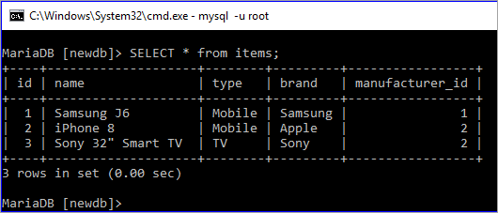

The following SQL command will display the values of **type** field by removing the duplicate values.

**SELECT DISTINCT type from items;**

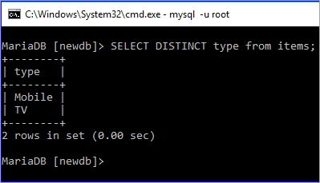

**Q #13) What is the difference between NOW() and CURRENT_DATE()?**

**Answer:**

Both **NOW()** and **CURRENT_DATE()** are built-in MySQL methods. **NOW()** is used to show the current date and time of the server and **CURRENT_DATE()** is used to show only the date of the server.

**SELECT now();**

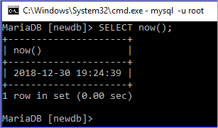

**SELECT current_date();**

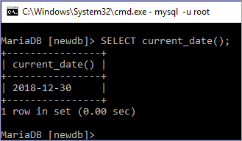

**Q #14) Which statement is used in a select query for partial matching?**

**Answer:**

**REGEXP** and **LIKE** statements can be used in a select query for partial matching. REGEXP is used to search records based on the pattern and LIKE is used to search any record by matching any string at the beginning or end or middle of a particular field value.

**Example:**

First, check the existing records of the ‘**clients'** table by executing the select query.

**SELECT * FROM clients;**

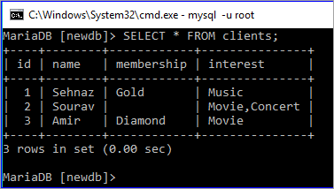

Run SELECT query with REGEXP clause to search those records from the **clients** where the client name starts with ‘**S**’

**SELECT * FROM clients WHERE name REGEXP “^S”;**

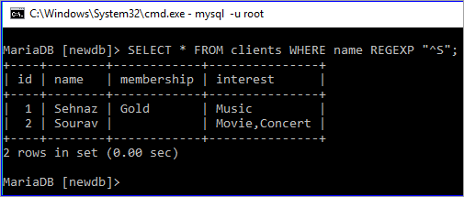

Run SELECT query with LIKE clause to search those records from the **clients** where the client name starts with ‘**A**’

**SELECT * FROM clients WHERE name LIKE “A%”;**

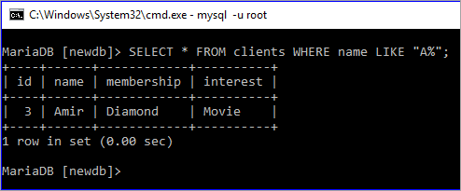

**Q #15) Which MySQL function is used to concatenate string?**

**Answer:**

**CONCAT()** function is used to combine two or more string data. The use of this function is here with an example.

**Example:**

The following SELECT query with CONCAT() function will combine five words, ‘Welcome ‘, ‘to’, ‘SoftwareTestingHelp’,’.’ and ‘com’.

**SELECT CONCAT(‘Welcome ‘,to ‘,'SoftwareTestingHelp','.',com');**

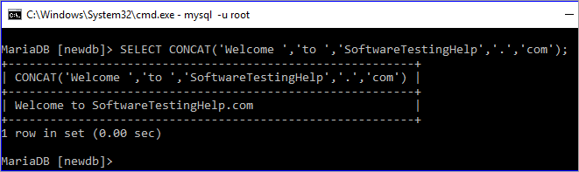

CONCAT() function can be used on any table as well. The following SELECT query will show the output by combining two fields, **brand** and **type** of **items** table.

**SELECT CONCAT(brand,'=>',type) from items;**

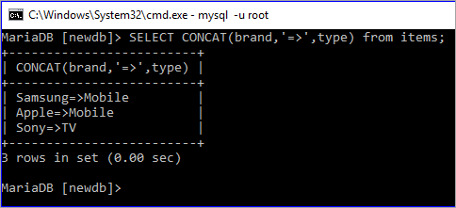

**Q #16) How can you change the name of any existing table by using the SQL statement?**

**Answer:**

The following SQL command is used to rename an existing table of the database.

**RENAME TABLE table_name TO new_name**

**Example:**

The following command will show the table list of the **newdb** database.

**SHOW TABLES;**

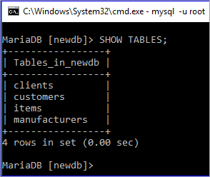

The following rename command will rename the table **items** by new name **products**.

**RENAME TABLE items TO products;**

**SHOW TABLES;**

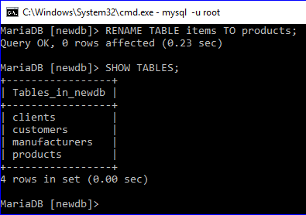

**Q #17) How can you retrieve a portion of any column value by using a select query?**

**Answer:**

**SUBSTR()** function is used to retrieve the portion of any column. The use of this function is explained here with an example.

**Example:**

Here, the first select command is used to show all the records of the products table and the second select command is executed using SUBSTR function and that prints only the first five characters of the name field.

**SELECT * FROM products;**

**SELECT SUBSTR(name,1,5) FROM products;**

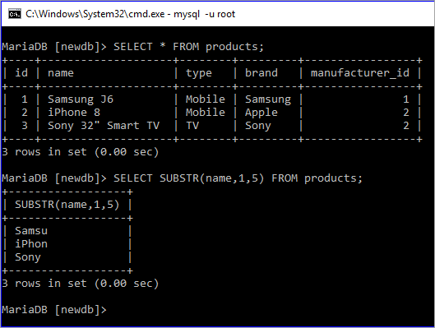

**Q #18) What is the purpose of using a HEAP table?**

**Answer:**

The table which uses a hashed index and stores in the memory is called HEAP table. It works as a temporary table and it uses the indexes that make it faster than another table type.

When MySQL crashes for any reason then all the data stored in this table can be lost. It uses fixed length data types. Hence BLOB and TEXT data types are not supported by this table. It is a useful table for those MySQL tasks where speed is the most important factor and temporary data is used.

**Q #19) How can you add and remove any column of a table?**

**Answer:**

The syntax for adding any column in an existing table is shown below.

**ALTER TABLE table_name ADD COLUMN column_name column_definition [FIRST|AFTER existing_column]**

**Example:**

DESCRIBE command is used to show the structure of the products table.

**DESCRIBE products;**

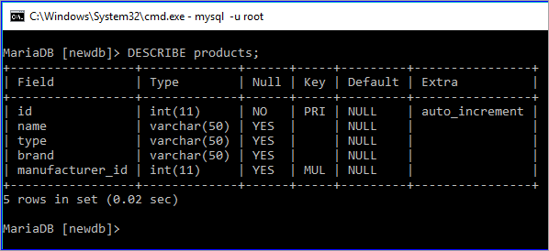

The following ALTER command with ADD COLUMN clause will add a new field named ‘**price'** in the table **products**.

**ALTER TABLE products ADD COLUMN price DECIMAL(5,2);**

**DESCRIBE products;**

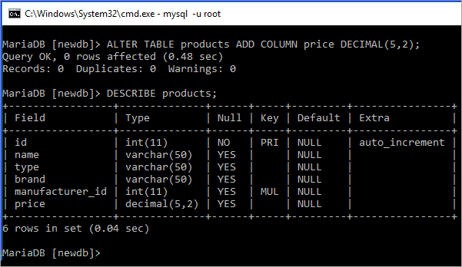

The syntax for removing any column from an existing table is shown below.

**ALTER TABLE table_name DROP COLUMN column_name;**

**Example:**

The following ALTER command with a DROP COLUMN clause will remove the field named ‘**brand'** in the table ‘**products'**.

**ALTER TABLE products DROP COLUMN brand;**

**DESCRIBE products;**

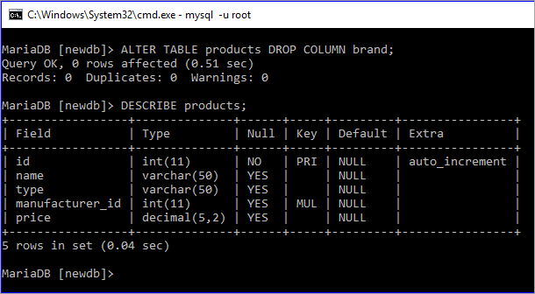

**Q #20) What is an index? How can an index be declared in MySQL?**

**Answer:**

An index is a data structure of MySQL table that is used to speed up the queries.

It is used by the database search engine to find out the records faster. One or more fields of a table can be used as an index key. Index key can be assigned at the time of table declaration or can be assigned after creating the table.

**Example:**

**username** and **email** fields are set as the index in the following create table statement.

|  |  |
| --- | --- |
| 1 | **CREATE** **TABLE** users( |

|  |  |
| --- | --- |
| 2 | username **VARCHAR**(50) **PRIMARY** **KEY**, |

|  |  |
| --- | --- |
| 3 | email **VARCHAR**(50) NOT NULL, |

|  |  |
| --- | --- |
| 4 | **password** **VARCHAR**(50) NOT NULL, |

|  |  |
| --- | --- |
| 5 | **INDEX** (username, email)); |

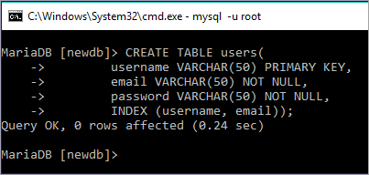

The following command will show the index key information of the ‘**users'** table.

**SHOW INDEXES FROM users;**

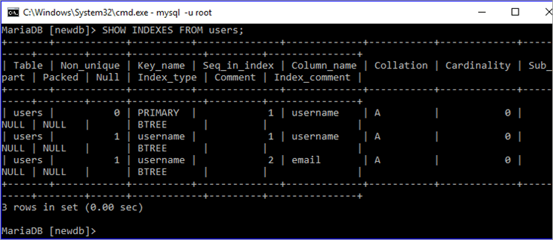

**Q #21) What is meant by decimal (5,2)?**

**Answer:**

A decimal data type is used in MySQL to store the fractional data.

The meaning of decimal (5,2) means that the total length of the fractional value is 5. The field can contain 3 digits before the decimal point and 2 digits after the decimal point. If a user adds any value larger than the defined length then it will insert 999.99 in the field.

The use of this data type is explained in the following example.

**Example:**

In the following insert query, **789.56** is inserted in the **price** field. This value is less than 1000 and the total digits with the fractional part are 5. So, this value is valid for this field.

|  |  |
| --- | --- |
| 1 | **INSERT** **INTO** products (type, **name**, price, manufacturer_id) |

|  |  |
| --- | --- |
| 2 | **VALUES** ('Mobile', 'iPhone 8', 789.56, 1); |

|  |  |
| --- | --- |
| 3 | **SELECT** * **FROM** products; |

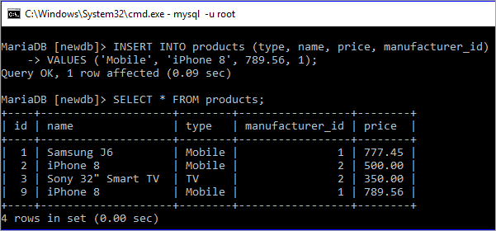

In the following insert query, **34789.567** is set for the price field. Then this value is greater than 1000 and the total digits with fractional part are 8. So, the default value 999.99 is inserted in the place of 34789.567**.**

|  |  |
| --- | --- |
| 1 | **INSERT** **INTO** products (type, **name**, price, manufacturer_id) |

|  |  |
| --- | --- |
| 2 | **VALUES**('TV','Sony 32" Smart TV',34789.567, 2); |

|  |  |
| --- | --- |
| 3 | **SELECT** * **FROM** products; |

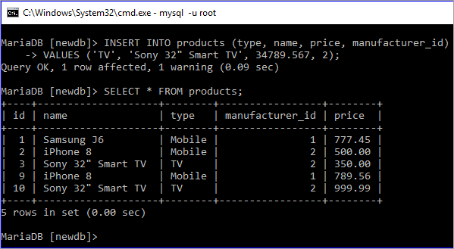

**Q #22) What is view? How can you create and drop view in MySQL?**

**Answer:**

A view works as a virtual table that is used to store query and returns a result set when it is called. An updatable view is also supported by MySQL.

The ways in which a view can be created or deleted in MySQL is shown in the following examples.

**Create View Example:**

The following statement will create a view file named ‘**client_list**’ based on the table **clients**.

**CREATE VIEW `client_list` AS SELECT `name` as ‘Name', `membership` as ‘Membership' FROM `clients`;**

Select statement will display the records of **client_list** value.

**SELECT * FROM client_list;**

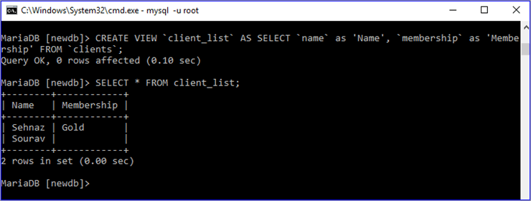

**Drop View Example:**

Drop view statement will delete the view file. Select query will show an error after deleting the view.

**DROP VIEW client_list;**

**SELECT * FROM client_list;**

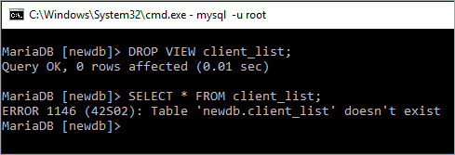

**Q #23) What is the function of mysqldump?**

**Answer:**

mysqldump is an useful utility tool of MySQL that is used to dump one or more or all databases from the server for backup or transfer to another database server.

**Syntax:**

For a single database,

**mysqldump [OPTIONS] db_name [TABLES]**

For multiple databases,

**mysqldump [OPTIONS] –databases DB1 [DB2 DB3…]**

For all databases,

**mysqldump [OPTIONS] –all-databases**

**Example:**

The following command will create a dump of the **‘newdb'** database and export the content of the database in the file, **newdb.sql**.

**mysqldump –databases newdb > newdb.sql**

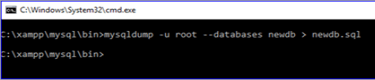

**Q #24) How can you change the password of a MySQL user?**

**Answer:**

SET **PASSWORD** statement is used to change the password of a MySQL user.

**Syntax:**

SET PASSWORD FOR ‘username'@'hostname' = PASSWORD(‘password');

**Example:**

The following statement will set or change the root password.

**SET PASSWORD FOR ‘root'@'localhost' = PASSWORD(‘123456');**

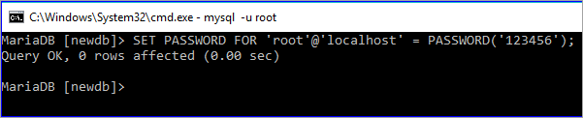

**Q #25) What is the difference between UNIX TIMESTAMP and MySQL TIMESTAMP?**

**Answer:**

Both UNIX TIMESTAMP and MySQL TIMESTAMP are used to represent the date and time value. The main difference between these values is that UNIX TIMESTAMP represents the value by using 32-bits integers and MySQL TIMESTAMP represents the value in the human-readable format.

**Example:**

A UNIX time value is used by FROM_UNIXTIME function in SELECT query to get the date and time value in the human-readable format.

**SELECT FROM_UNIXTIME (1596222320) AS ‘MySQLTIMESTAMP';**

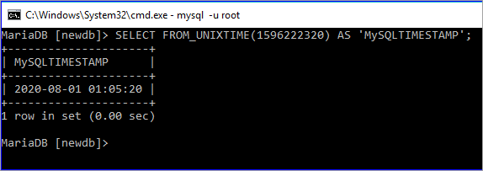

Date and time value is used by UNIX_TIMESTAMP function in SELECT query to get the date and time value in the UNIX format.

**SELECT UNIX_TIMESTAMP (‘2018-12-25 09:45:40') AS ‘UNIXTIMESTAMP';**

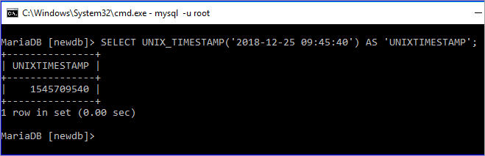

**Q #26) How can you import tables from a SQL file into a database by using the MySQL client?**

**Answer:**

Database tables can be imported into a database from a SQL file by using the following MySQL statement.

**mysql -u username -p database_name < sql_filename**

**Example:**

If the root user’s password is empty, then the following command will import tables from ‘newdb.sql’ file into the database **`mydb`.**

**mysql -u root mydb < newdb.sql**

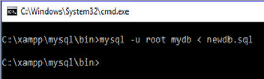

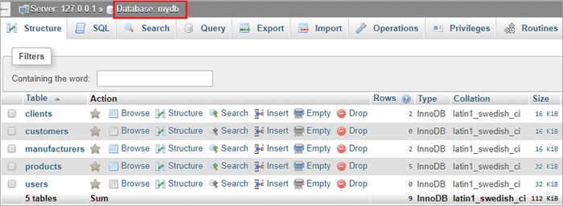

**Q #27) What is the difference between Primary key and Unique key?**

**Answer:**

Unique data is stored in the primary key and unique key fields. Primary key field never accepts NULL value but unique key field accepts a NULL value.

**Example:**

In the **users'** table, **id** field is the **primary key** and **email** field is a **unique key**. Two records are inserted in the table where the email field is NULL for the 2nd record. The records are inserted properly as the unique field supports a NULL value.

|  |  |
| --- | --- |
| 1 | **INSERT** **INTO** users (username, email, **password**) |

|  |  |
| --- | --- |
| 2 | **VALUES**('admin', '[admin@example.com](mailto:admin@example.com)', '7890'), |

|  |  |
| --- | --- |
| 3 | ('staff', 'NULL', '1234'); |

|  |  |
| --- | --- |
| 4 | **SELECT** * **FROM** users; |

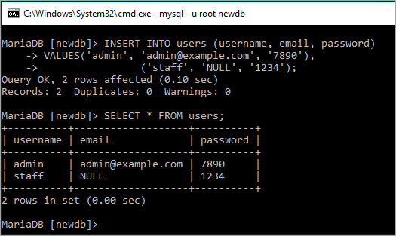

**Q #28) What is the purpose of using IFNULL() function?**

**Answer:**

**IFNULL()** function takes two arguments. It returns the first argument value if the value of the first argument is not NULL and it returns the second argument if the value of the first argument is NULL.

**Example:**

Here, the first argument of IFNULL function is not NULL. So, the output is the first argument value.

**SELECT IFNULL (“Tutorial”, “fahmidasclassroom.com”);**

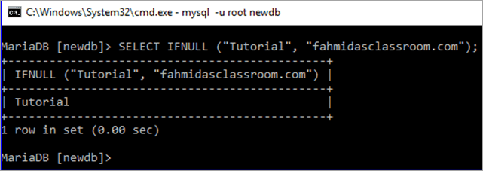

Here, the first argument of IFNULL function is NULL. So, the output is NULL.

**SELECT IFNULL (“NULL”, “fahmidasclassroom.com”);**

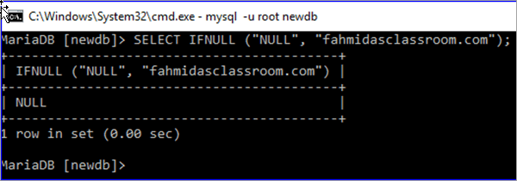

**Q #29) What is a join? Explain the different types of MySQL joins.**

**Answer:**

The SQL statement that is used to make a connection between two or more tables based on the matching columns is called a join. It is mainly used for complex queries.

**Different types of SQL joins are mentioned below:**

* **Inner Join**: It is a default join. It returns records when the values match in the joining tables.
* **Left Outer Join**: It returns all the records from the left table based on the matched records from the right table.
* **Right Outer Join**: It returns all the records from the right table based on the matched records from the left table.
* **Full Outer Join**: It returns all the records that match from the left or right table.

**Example:**

Two tables, **manufacturers** and **products** are used in this example to show the use of INNER JOIN. Here, SELECT queries are used to show the current records of these two tables.

**SELECT * FROM manufacturers;**

**SELECT * FROM products;**

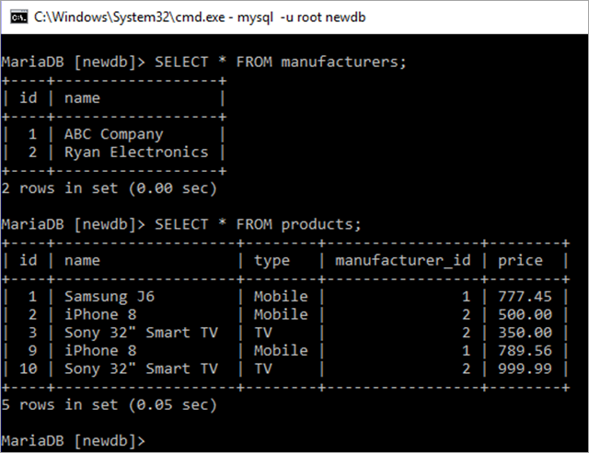

INNER JOIN is used in the following SELECT query where all the id and name of products table will be displayed based on matching **manufacturer_id** of the **products** with an **id** of the **manufacturers** table.

|  |  |
| --- | --- |
| 1 | **SELECT** products.id, products.**name** |

|  |  |
| --- | --- |
| 2 | **FROM** products |

|  |  |
| --- | --- |
| 3 | **INNER** JOIN manufacturers **ON** manufacturers.id= products.manufacturer_id; |

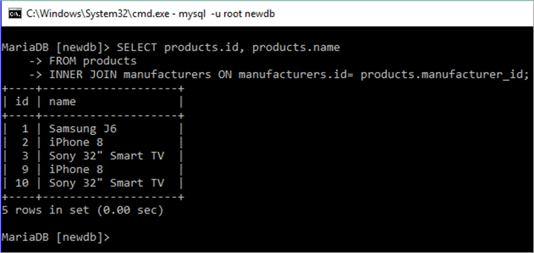

**Q #30) How can you retrieve a particular number of records from a table?**

**Answer:**

**LIMIT** clause is used with the SQL statement to retrieve a particular number of records from a table. From which record and how many records will be retrieved are defined by the LIMIT clause.

**Syntax:**

LIMIT starting_number, number_of_rows

**Example:**

Products table has 5 records which are displayed by the first select query and the second select query is used to display the records from 2nd to 3rd by using LIMIT 1, 2.

**SELECT * FROM products;**

**SELECT * FROM products LIMIT 1, 2;**

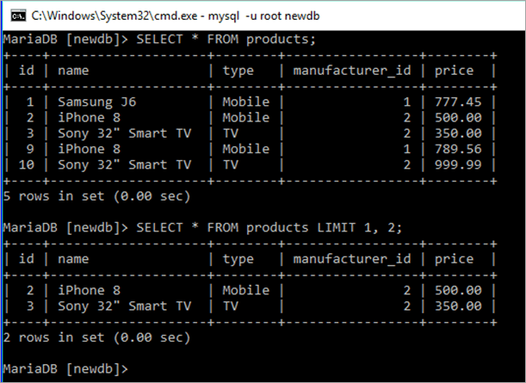

**Q #31) How can you export the table as an XML file in MySQL?**

**Answer:**

‘-X’ option is used with `mysql` command for exporting the file as XML. The following statement will export any table from a database as an XML file.

**mysql -u username -X -e “SELECT query” database_name**

**Example:**

The following command will export the data of the **items** table into **an xmlData.xml** file.

mysql -u root -X -e “SELECT * from products” newdb > xmlData.xml

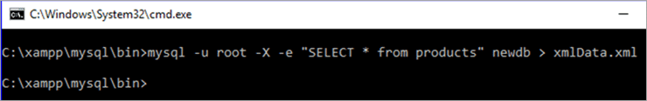

**Q #32) What is a CSV table?**

**Answer:**

MySQL table that uses CSV storage engine is called a CSV table. Data are stored as comma-separated values in the CSV table. MySQL server creates a data file with an extension ‘.csv’ to store the content of the CSV table.

**Example:**

The following create statement will create a CSV file named book.

**CREATE TABLE book ( id INT NOT NULL) ENGINE=CSV;**

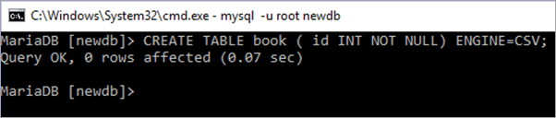

**Q #33) How can you calculate the sum of any column of a table?**

**Answer:**

**SUM()** function is used to calculate the sum of any column.

**Syntax:**

SUM(DISTINCT expression)

**Example:**

Products table has a numeric field named, price. In this example, the **SUM() function** is used to calculate the total value of the **price** field.

|  |  |
| --- | --- |
| 1 | **SELECT** * **FROM** products; |

|  |  |
| --- | --- |
| 2 | **SELECT** SUM(price) **as** total **FROM** products; |

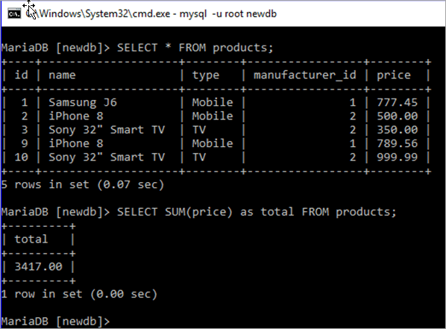

**Q #34) How can you count the total number of records of any table?**

**Answer:**

**COUNT()** function is used to count the total number of records of any table.

**Syntax:**

COUNT(expression)

**Example:**

The following select query is used to count the total number of records of the **products** table.

**SELECT COUNT(*) as `Total Records` FROM products;**

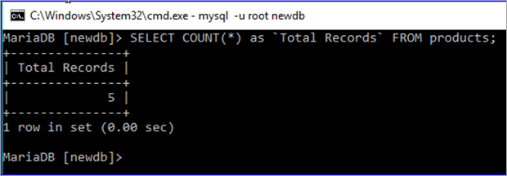

**Q #35) Explain the difference between delete and truncate.**

**Answer:**

Both DELETE and TRUNCATE commands are used to delete the records from any database table. However, there are some significant differences between these commands. If the table contains AUTO_INCREMENT PRIMARY KEY field then the effect of these commands can be shown properly.

**Two differences between these commands are mentioned below.**

**#1)** DELETE command is used to delete a single or multiple or all the records from the table. TRUNCATE command is used to delete all the records from the table or make the table empty.

**#2)** When DELETE command is used to delete all the records from the table then it doesn’t re-initialize the table. So, AUTO_INCREMENT field does not count from one when the user inserts any record.

But when all the records of any table are deleted by using TRUNCATE command then it re-initializes the table and a new record will start from one for the AUTO_INCREMENT field.

**Example:**

Previously created users table is used in this example.

First, the SELECT query will show all the records of the users table. DELETE query will delete all the records from the user's table. INSERT query will insert a new record into the users table. After insert, if the SELECT query executes again then it will be shown that a new **id** is calculated after the deleted **id**.

|  |  |
| --- | --- |
| 1 | **SELECT** * **FROM** users; |

|  |  |
| --- | --- |
| 2 | **DELETE** **FROM** users; |

|  |  |
| --- | --- |
| 3 | **INSERT** **INTO** users (username, email) |

|  |  |
| --- | --- |
| 4 | **VALUES** ('Durjoy', '[durjoy@gmail.com](mailto:durjoy@gmail.com)'); |

|  |  |
| --- | --- |
| 5 | **SELECT** * **FROM** users; |

Currently, there are two records in the users table and when a new record is inserted after deleting all the records then the new id is 3, and not 1.

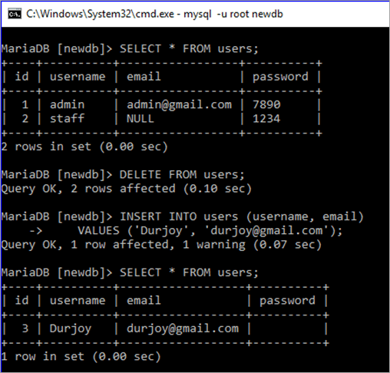

Same queries are executed in this part, just used TRUNCATE statement in place of DELETE. It is shown that the id value of the new record is 1.

|  |  |
| --- | --- |
| 1 | **TRUNCATE** **table** users; |

|  |  |
| --- | --- |
| 2 | **INSERT** **INTO** users (username, email) |

|  |  |
| --- | --- |
| 3 | **VALUES** ('Farheen', '[farheen@gmail.com](mailto:farheen@gmail.com)'); |

|  |  |
| --- | --- |
| 4 | **SELECT** * **FROM** users; |

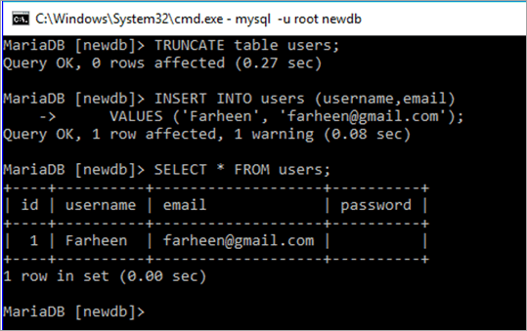

**Q #36) What is a storage engine? What are the differences between InnoDB and MyISAM engines?**

**Answer:**

One of the major components of the MySQL server is the storage engine for doing different types of database operations. Each database table created is based on the specific storage engine.

MySQL supports two types of storage engines i.e **transactional and non-transactional**. InnoDB is the default storage engine of MySQL which is a transactional storage engine. MyISAM storage engine is a non-transactional storage engine.

**The differences between InnoDB and MyISAM storage engines are discussed below:**

* MyISAM supports FULLTEXT index but InnoDB doesn’t support FULLTEXT index.
* MyISAM is faster and InnoDB is slower.
* InnoDB supports ACID (Atomicity, Consistency, Isolation, and Durability) property but MyISAM doesn’t.
* InnoDB supports row-level locking and MyISAM support table-level locking.
* InnoDB is suitable for large database and MyISAM is suitable for a small database.

**Q #37) What is a transaction? Describe MySQL transaction properties.**

**Answer:**

When a group of database operations is done as a single unit then it is called a transaction. If any task of the transactional tasks remains incomplete then the transaction will not succeed. Hence, it is mandatory to complete all the tasks of a transaction to make the transaction successful.

A transaction has four properties which are known as ACID property. These properties are described below.

* **Atomicity:** It ensures that all the tasks of a transaction will be completed successfully otherwise all the completed tasks will be rolled back to the previous state for any failure.
* **Consistency:** It ensures that the database state must be changed accurately for the committed transaction.
* **Isolation:** It ensures that all the tasks of a transaction will be done independently and transparently.
* **Durability:** It ensures that all the committed transaction is consistent for any type of system failure.

**Q #38) What are the functions of commit and rollback statements?**

**Answer:**

Commit is a transaction command that executes when all the tasks of a transaction are completed successfully. It will modify the database permanently to confirm the transaction.

**Syntax:**

COMMIT;

Rollback is another transactional command that executes when any of the transactional tasks becomes unsuccessful and undoes all the changes that are made by any transactional task to make the transaction unsuccessful.

**Syntax:**

ROLLBACK;

**Q #39) What is the difference between MyISAM static and MyISAM dynamic?**

**Answer:**

MyISAM static and MyISAM dynamic are the variations of the MyISAM storage engine. The differences between these tables are mentioned below.

* All the fields of MyISAM static table are of a fixed length and MyISAM dynamic table accepts variable length fields such as BLOB, TEXT etc.
* After data corruption, it is easier to restore MyISAM static table than MyISAM dynamic table.

**Q #40) What is a trigger? How you can create a trigger in MySQL?**

**Answer:**

One of the important features of the MySQL database is a trigger that executes automatically when a particular database event occurs.

It fires after or before the execution of an insert or update or delete statement. It is a very useful option when a database user wants to do some database operations automatically.

**Trigger Example:**

If you want to delete the items of a supplier from the **items** table automatically after deleting the entry of the particular supplier from the ‘**suppliers'** table then write the trigger in the following way.

**Example:**

This is an example of after delete trigger that will fire automatically when any record is removed from the **manufacturer** table and deletes all the records from the **products** table where the deleted **id** of the **manufacturer** table matches with the **manufacturer_id** field of the **products** table.

|  |  |
| --- | --- |
| 1 | DELIMITER // |

|  |  |
| --- | --- |
| 2 | **CREATE** **TRIGGER** manufacturer_after_delete |

|  |  |
| --- | --- |
| 3 | **AFTER** **DELETE** |

|  |  |
| --- | --- |
| 4 | **ON** manufacturers **FOR** EACH ROW |

|  |  |
| --- | --- |
| 5 | **BEGIN** |

|  |  |
| --- | --- |
| 6 | **DELETE** **FROM** products **WHERE** products.manufacturers_id = OLD.id; |

|  |  |
| --- | --- |
| 7 | **END**; |

|  |  |
| --- | --- |
| 8 | // |

### TRIGGER in MySQL

That’s all for now on MySQL questions, I will be coming up with another set of questions soon. Don’t forget to provide your valuable feedback in comment section.

###### 1. How would you check if MySql service is running or not?

Answer : Issue the command “service mysql status” in ‘Debian’ and “service mysqld status” in RedHat. Check the output, and all done.

root@localhost:/home/avi# **service mysql status**/usr/bin/mysqladmin Ver 8.42 Distrib 5.1.72, for debian-linux-gnu on i486Copyright (c) 2000, 2013, Oracle and/or its affiliates. All rights reserved.Oracle is a registered trademark of Oracle Corporation and/or itsaffiliates. Other names may be trademarks of their respectiveowners.Server version 5.1.72-2Protocol version 10Connection Localhost via UNIX socketUNIX socket /var/run/mysqld/mysqld.sockUptime: 1 hour 22 min 49 secThreads: 1 Questions: 112138 Slow queries: 1 Opens: 1485 Flush tables: 1 Open tables: 64 Queries per second avg: 22.567.

###### 2. If the service is running/stop how would you stop/start the service?

Answer : To start MySql service use command as service mysqld start and to stop use service mysqld stop.

root@localhost:/home/avi# **service mysql stop**Stopping MySQL database server: mysqld.root@localhost:/home/avi# **service mysql start**Starting MySQL database server: mysqld.Checking for corrupt, not cleanly closed and upgrade needing tables..

###### 3. How will you login to MySQL from Linux Shell?

Answer : To connect or login to MySQL service, use command: mysql -u root -p.

root@localhost:/home/avi# **mysql -u root -p** Enter password: Welcome to the MySQL monitor. Commands end with ; or \g. Your MySQL connection id is 207 Server version: 5.1.72-2 (Debian) Copyright (c) 2000, 2013, Oracle and/or its affiliates. All rights reserved. Oracle is a registered trademark of Oracle Corporation and/or its affiliates. Other names may be trademarks of their respective owners. Type 'help;' or '\h' for help. Type '\c' to clear the current input statement. mysql>

###### 4. How will you obtain list of all the databases?

Answer : To list all currently running databases run the command on mysql shell as: show databases;

mysql> **show databases;** +--------------------+ | Database | +--------------------+ | information_schema | | a1 | | cloud | | mysql | | phpmyadmin | | playsms | | sisso | | test | | ukolovnik | | wordpress | +--------------------+ 10 rows in set (0.14 sec)

###### 5. How will you switch to a database, and start working on that?

Answer : To use or switch to a specific database run the command on mysql shell as: use database_name;

mysql> **use cloud;** Reading table information for completion of table and column names You can turn off this feature to get a quicker startup with -A Database changed mysql>

###### 6. How will you get the list of all the tables, in a database?

Answer : To list all the tables of a database use the command on mysql shell as: show tables;

mysql> **show tables;** +----------------------------+ | Tables_in_cloud | +----------------------------+ | oc_appconfig | | oc_calendar_calendars | | oc_calendar_objects | | oc_calendar_repeat | | oc_calendar_share_calendar | | oc_calendar_share_event | | oc_contacts_addressbooks | | oc_contacts_cards | | oc_fscache | | oc_gallery_sharing | +----------------------------+ 10 rows in set (0.00 sec)

###### 7. How will you get the Field Name and Type of a MySql table?

Answer : To get the Field Name and Type of a table use the command on mysql shell as: describe table_name;

mysql> **describe oc_users;** +----------+--------------+------+-----+---------+-------+ | Field | Type | Null | Key | Default | Extra | +----------+--------------+------+-----+---------+-------+ | uid | varchar(64) | NO | PRI | | | | password | varchar(255) | NO | | | | +----------+--------------+------+-----+---------+-------+ 2 rows in set (0.00 sec)

###### 8. How will you delete a table?

Answer : To delte a specific table use the command on mysql shell as: drop table table_name;

mysql> **drop table lookup;** Query OK, 0 rows affected (0.00 sec)

###### 9. What about database? How will you delete a database?

Answer : To delte a specific database use the command on mysql shell as: drop database database-name;

mysql> **drop database a1;** Query OK, 11 rows affected (0.07 sec)

###### 10. How will you see all the contents of a table?

Answer : To view all the contents of a particular table use the command on mysql shell as: select * from table_name;

mysql> **select * from engines;** +------------+---------+----------------------------------------------------------------+--------------+------+------------+ | ENGINE | SUPPORT | COMMENT | TRANSACTIONS | XA | SAVEPOINTS | +------------+---------+----------------------------------------------------------------+--------------+------+------------+ | InnoDB | YES | Supports transactions, row-level locking, and foreign keys | YES | YES | YES | | MRG_MYISAM | YES | Collection of identical MyISAM tables | NO | NO | NO | | BLACKHOLE | YES | /dev/null storage engine (anything you write to it disappears) | NO | NO | NO | | CSV | YES | CSV storage engine | NO | NO | NO | | MEMORY | YES | Hash based, stored in memory, useful for temporary tables | NO | NO | NO | | FEDERATED | NO | Federated MySQL storage engine | NULL | NULL | NULL | | ARCHIVE | YES | Archive storage engine | NO | NO | NO | | MyISAM | DEFAULT | Default engine as of MySQL 3.23 with great performance | NO | NO | NO | +------------+---------+----------------------------------------------------------------+--------------+------+------------+ 8 rows in set (0.00 sec)

###### 11. How will you see all the data in a field (say, uid), from table (say, oc_users)?

Answer : To view all the data in a field use the command on mysql shell as: select uid from oc_users;

mysql> **select uid from oc_users;** +-----+ | uid | +-----+ | avi | +-----+ 1 row in set (0.03 sec)

###### 12. Say you have a table ‘xyz’, which contains several fields including ‘create_time’ and ‘engine’. The field ‘engine’ is populated with two types of data ‘Memory’ and ‘MyIsam’. How will you get only ‘create_time’ and ‘engine’ from the table where engine is ‘MyIsam’?

Answer : Use the command on mysql shell as: select create_time, engine from xyz where engine=”MyIsam”;

12. mysql> **select create_time, engine from xyz where engine="MyIsam";**+---------------------+--------+ | create_time | engine | +---------------------+--------+ | 2013-12-15 13:43:27 | MyISAM | | 2013-12-15 13:43:27 | MyISAM | | 2013-12-15 13:43:27 | MyISAM | | 2013-12-15 13:43:27 | MyISAM | | 2013-12-15 13:43:27 | MyISAM | | 2013-12-15 13:43:27 | MyISAM | | 2013-12-15 13:43:27 | MyISAM | | 2013-12-15 13:43:27 | MyISAM | | 2013-10-23 14:56:38 | MyISAM | | 2013-10-23 14:56:38 | MyISAM | | 2013-10-23 14:56:38 | MyISAM | | 2013-10-23 14:56:38 | MyISAM | | 2013-10-23 14:56:38 | MyISAM | | 2013-10-23 14:56:38 | MyISAM | | 2013-10-23 14:56:38 | MyISAM | +---------------------+--------+ 132 rows in set (0.29 sec)

###### 13. How will you show all the records from table ‘xrt’ where name is ‘tecmint’ and web_address is ‘tecmint.com’?

Answer : Use the command on mysql shell as: select * from xrt where name = “tecmint” and web_address = “tecmint.com”;

mysql> **select * from xrt where name = "tecmint" and web_address = “tecmint.com”;**+---------------+---------------------+---------------+ | Id | name | web_address | +---------------+---------------------+----------------+ | 13 | tecmint | tecmint.com |+---------------+---------------------+----------------+ | 41 | tecmint | tecmint.com |+---------------+---------------------+----------------+

###### 14. How will you show all the records from table ‘xrt’ where name is not ‘tecmint’ and web_address is ‘tecmint.com’?

Answer : Use the command on mysql shell as: select * from xrt where name != “tecmint” and web_address = “tecmint.com”;

mysql> **select * from xrt where name != ”tecmint” and web_address = ”tecmint.com”;**+---------------+---------------------+---------------+ | Id | name | web_address | +---------------+---------------------+----------------+ | 1173 | tecmint | tecmint.com |+---------------+---------------------+----------------+

###### 15. You need to know total number of row entry in a table. How will you achieve it?

Answer : Use the command on mysql shell as: select count(*) from table_name;

mysql> **select count(*) from Tables;** +----------+ | count(*) | +----------+ | 282 | +----------+ 1 row in set (0.01 sec)